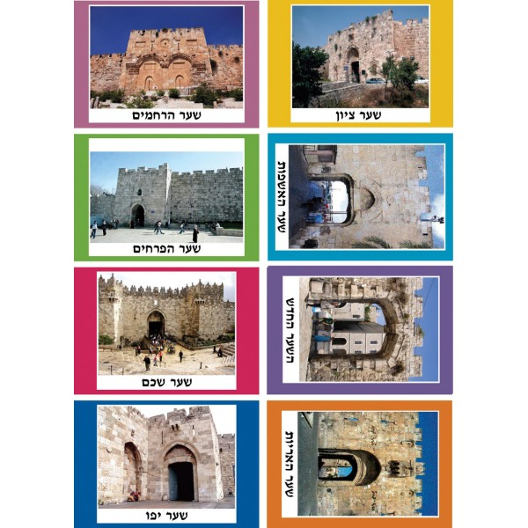

[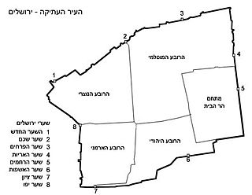](https://he.wikipedia.org/wiki/%D7%A7%D7%95%D7%91%D7%A5:Jerusalem_oldcity1.jpg)