_ a _
at, man, hat, sad, Dan, mad, map, dad, black, sad, cat, has
קראו את הסיפור. ענו על השאלות. צבעו את התמונה לפי הסיפור.
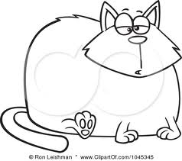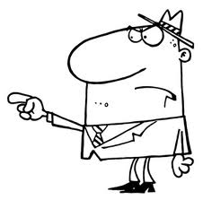 |  | This is Dan.  Dan is a man.  Dan has a fat, black cat.  Dan has a green hat.  The cat sat on the hat.  Dan is mad.
The cat is __________  - fat and blue  - small and black  - fat and black | Dan is __________  - sad  - mad  - bad |  | Dan has a __________  - mat  - cat and a hat  - mad

