Circle the words that have the long e sound,
then write each word in the blank to match the picture.

red sleep tree feet jet bees

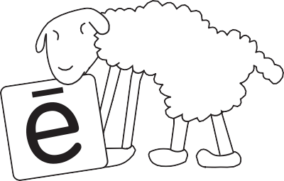1. 2.
If I see a
I say e !
double e,
Pete’s Sheep
TM
sle ep

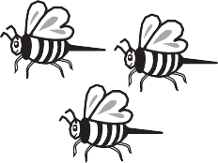
3. 4.

Comments welcome at www.starfall.com/feedback
37

Name

Circle the word that best completes the sentence, then write the word in the blank.

- I see bees.
- I brush my .
- The eat grass.
- Zac likes .
tree three me
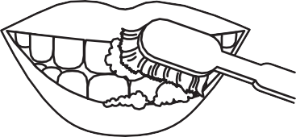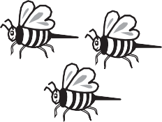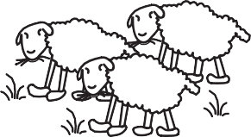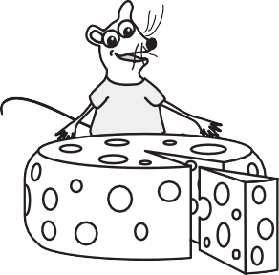teeth feed tale
she keep sheep
cheese cheek sees

Zac

38 Comments welcome at www.starfall.com/feedback

Name
sh shells

Use sh

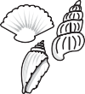to complete each word to match the picture,

then say the word.
- 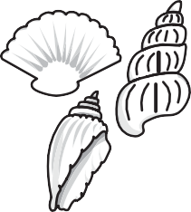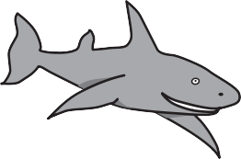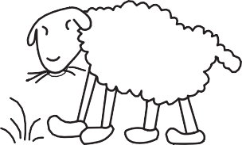 shells 2.
eep
3.
4.
ark
ip

Write your own sentence using one of the
sh words above.

Teacher Note: If the r-controlled vowel “a” as in “shark” needs introduction, please see page 67.
Comments welcome at www.starfall.com/feedback
39

Name

Complete each word to rhyme with Hint: Use the picture clues to help.
think , then say the word.

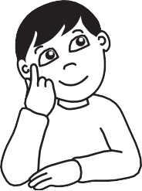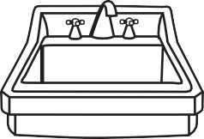1. th i nk 2.
- ink 4.
ink
ink

What color rhymes with think?
Color the crayon to match
your answer.
ink

Comments welcome at www.starfall.com/feedback
40

Name
Use wh or sh to complete each word to match the picture,

then say the word.
  - 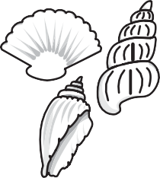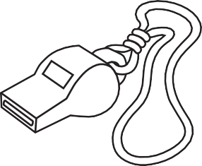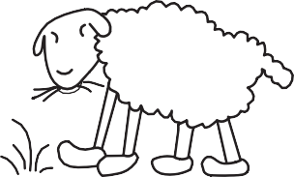 wheel 2.
3. eep 4.
ake
5.
6.
ells
iskers
istle

Color the pictures that show animals.

Teacher Note: “Whistle” is a useful word when used to teach the digraph /wh/, even though it is not fully decodable.
Comments welcome at www.starfall.com/feedback
41

Quotation Marks tell us the EXACT words a person is saying.

- 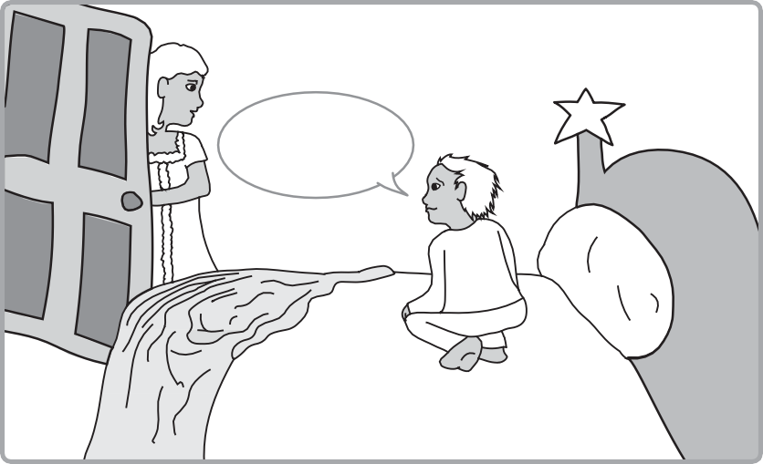Think of sheep, says
I can’t sleep, says Pete.
What do you think Pete’s mother will say to him?
I can’t sleep.
Read each sentence below,
then trace over the one you like.
TM
Remember to add quotation marks
.
Mother.
- Let ’s have pizza, says
Mother.
42 Comments welcome at www.starfall.com/feedback

