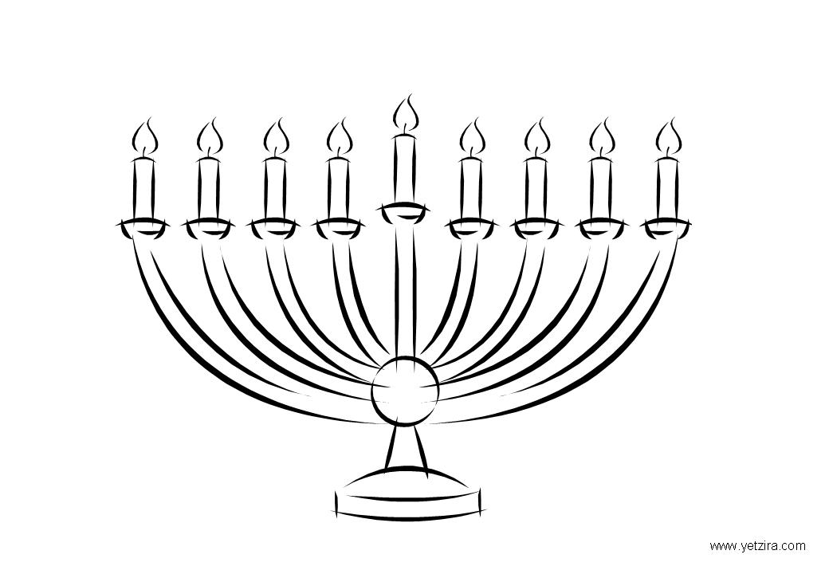
Hanukah

m | k | h | h | a | n | u | k | a | h
b | e | z | j | n | j | c | z | b | o
e | m | n | x | b | y | a | m | l | l
c | k | n | o | m | j | n | y | i | y
a | e | y | a | r | l | d | m | g | o
g | y | m | e | k | a | l | k | h | p
h | d | r | e | i | d | e | l | t | l
b | e | c | a | r | e | f | u | l | o

Write the meaning of the following words:
פרש את המילים הבאות
holiday- ______ menorah-______
candle-_______ holy-______ dreidel-_____
light-______ Hanukah-______
be careful-________

