בעזהי"ת

חַיּוֹת הַשָּׂדֶה אוֹמְרִים. בָּרוּךְ הַטּוֹב וְהַמֵּטִיב – מדבקה מספר 1

2

אִילָנוֹת שֶׁבְּשָׂדֶה אוֹמְרִים . אָז יְרַנְּנוּ עֲצֵי הַיָּעַר מִלִּפְנֵי יי כִּי בָא לִשְׁפּוֹט אֶת הָאָרֶץ: (דברי הימים א טז לח) - מדבקה מספר 3

4

[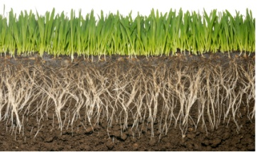](https://www.google.co.il/url?sa=i&rct=j&q=&esrc=s&source=images&cd=&cad=rja&uact=8&ved=0CAcQjRxqFQoTCI3-7Y_h5cYCFUM7FAod-rkLxA&url=https://www.blendspace.com/lessons/pLDTJt8xOc7bkQ/root-systems&ei=L9eqVc2qKsP2UPrzrqAM&bvm=bv.98197061,d.d24&psig=AFQjCNENsFd8Hv70h-09mAwFrWPsp0gzsQ&ust=1437345681352300)5

כל שמעשיו מרובין מחכמתו, למה הוא דומה, לאילן שענפיו מעטין ושורשיו מרובין, שאפילו כל הרוחות שבעולם באות ונושבות בו אין מזיזין אותו ממקומו – מדבקה מספר 6

[](http://www.google.co.il/url?sa=i&rct=j&q=&esrc=s&source=images&cd=&cad=rja&uact=8&ved=0CAcQjRxqFQoTCLe81vvp5cYCFUU3FAodLW0Aaw&url=http://xnet.ynet.co.il/diy/articles/0,14712,L-3103540,00.html&ei=deCqVfetEcXuUK3agdgG&bvm=bv.98197061,d.d24&psig=AFQjCNF2dmlOQQX18tlRYpqSe2bQvKz-tA&ust=1437348322384291)7

[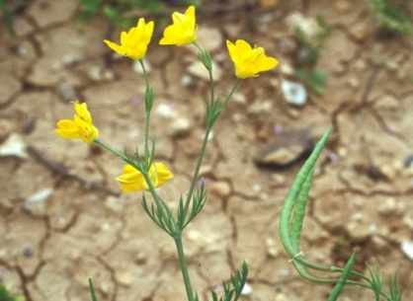](http://www.google.co.il/url?sa=i&rct=j&q=&esrc=s&source=images&cd=&cad=rja&uact=8&ved=0CAcQjRxqFQoTCNOshMvu5cYCFYayFAodYz4A1A&url=http://www.kalanit.org.il/index.php/2333/&ei=TeWqVZPSG4blUuP8gKAN&bvm=bv.98197061,d.d24&psig=AFQjCNH4zbGqzQ-GjuR5xAqIWFMFdxVamw&ust=1437349578606834)8

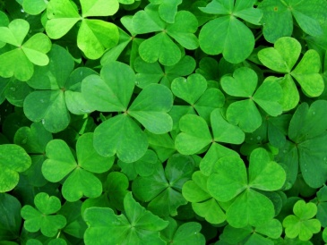9

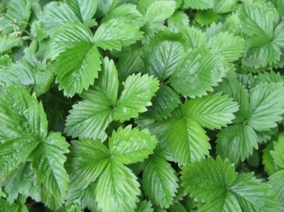10

11[](http://www.google.co.il/url?sa=i&rct=j&q=&esrc=s&source=images&cd=&cad=rja&uact=8&ved=0CAcQjRxqFQoTCNumzJzw5cYCFULTFAodoI0PgQ&url=http://travel.walla.co.il/item/2797494&ei=BOeqVduUOcKmU6CbvogI&bvm=bv.98197061,d.d24&psig=AFQjCNFxNMS96TRMI7FuiRi_UUslWCJ1Zg&ust=1437350005027016)

[](http://www.google.co.il/url?sa=i&rct=j&q=&esrc=s&source=images&cd=&cad=rja&uact=8&ved=0CAcQjRxqFQoTCIOp1NHr5cYCFUY5FAody0QEKQ&url=http://www.publicdomainpictures.net/view-image.php?large=1&image=7232&ei=NuKqVYO2AsbyUMuJkcgC&bvm=bv.98197061,d.d24&psig=AFQjCNFlzgcwRcIAoHNMMzhTfAcdjIZjzQ&ust=1437348770765305)12

[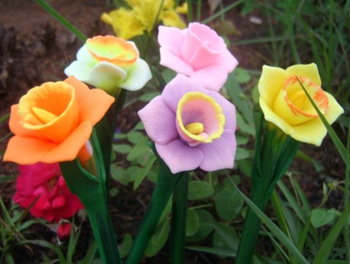](http://www.google.co.il/url?sa=i&rct=j&q=&esrc=s&source=images&cd=&cad=rja&uact=8&ved=0CAcQjRxqFQoTCNjnht3x5cYCFQZVFAodK-gLtw&url=http://www.aliexpress.com/item-img/Vivid-Handmade-Narcissus-Flower-Gel-Pen-Ball-Point-Pen-Giveaways-Promotional-Products-100-pc-a-lot/309462313.html&ei=mOiqVdi7IYaqUavQr7gL&bvm=bv.98197061,d.d24&psig=AFQjCNEuHDk7qIXTNNnKZGyf3Cb2yo9vzQ&ust=1437350409737562)13

[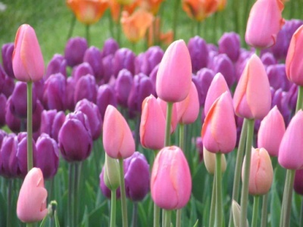](http://www.google.co.il/url?sa=i&rct=j&q=&esrc=s&source=images&cd=&cad=rja&uact=8&ved=0CAcQjRxqFQoTCNONpY_z5cYCFQm6FAodamUHxg&url=http://www.gardens.co.il/htmls/%D7%91%D7%A6%D7%9C%D7%99%D7%9D_%D7%95%D7%A4%D7%A7%D7%A2%D7%95%D7%AA_%D7%A9%D7%AA%D7%99%D7%9C%D7%94.aspx?c0=17018&bsp=17017&ei=DuqqVdPOFIn0UurKnbAM&bvm=bv.98197061,d.d24&psig=AFQjCNF-FmlCcvUtiQHA1TdFXLpJx-L35g&ust=1437350785014183)14

[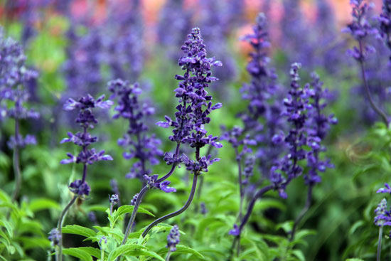](http://www.google.co.il/url?sa=i&rct=j&q=&esrc=s&source=images&cd=&cad=rja&uact=8&ved=0CAcQjRxqFQoTCL3Cstzz5cYCFURWFAodoQwG0w&url=http://lizhi.qq1688.org/lizhikuaixun/2015-05-31/96657.html&ei=sOqqVb2qAsSsUaGZmJgN&bvm=bv.98197061,d.d24&psig=AFQjCNH39bjRbBNQvKiZAAYdgFYvv1GHvQ&ust=1437350925319639)15

[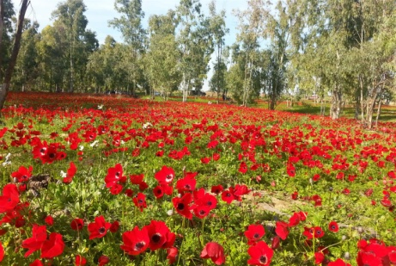](http://www.google.co.il/url?sa=i&rct=j&q=&esrc=s&source=images&cd=&cad=rja&uact=8&ved=0CAcQjRxqFQoTCMHC1aH15cYCFcXAFAodGPsOIQ&url=http://www.eyarok.org.il/KidsIsland/trip.aspx?id=1778&ei=TeyqVYHoLcWBU5j2u4gC&bvm=bv.98197061,d.d24&psig=AFQjCNGvFHLJY8bGVOw8Wzy-su7v6UONIw&ust=1437351332745639)16

[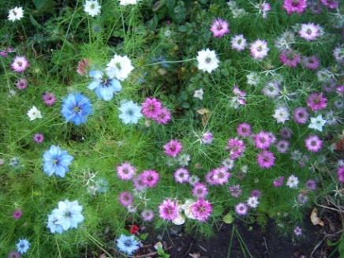](https://www.google.co.il/url?sa=i&rct=j&q=&esrc=s&source=images&cd=&cad=rja&uact=8&ved=0CAcQjRxqFQoTCN2mroz25cYCFQEXFAodDt8HxQ&url=https://www.reddit.com/r/AskWomen/comments/327ygk/what_are_your_favorite_flowers/&ei=Le2qVZ3cHoGuUI6-n6gM&bvm=bv.98197061,d.d24&psig=AFQjCNFgv425HpCHudMVUYTpcVVxspINBQ&ust=1437351591302918)17

[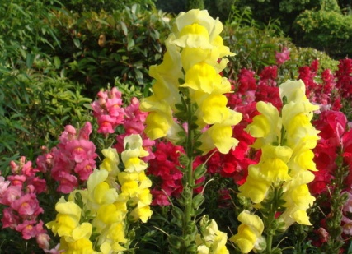](http://www.google.co.il/url?sa=i&rct=j&q=&esrc=s&source=images&cd=&cad=rja&uact=8&ved=0CAcQjRxqFQoTCLbH2JKt58YCFYLTFAodjhwC_g&url=http://he.aliexpress.com/w/wholesale-snapdragons-flower.html&ei=Hq2rVbbAHIKnU465iPAP&bvm=bv.98197061,d.d24&psig=AFQjCNH-qCZ6xpyRZ3-7bpeyeI9QfoFi6w&ust=1437400656901351)18

[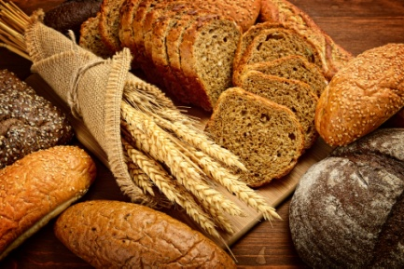](http://www.google.co.il/url?sa=i&rct=j&q=&esrc=s&source=images&cd=&cad=rja&uact=8&ved=0CAcQjRxqFQoTCJjQ4J-y58YCFQTxFAod5koEjQ&url=http://www.etmikra.cet.ac.il/%D7%A9%D7%9C%D7%95%D7%A9%D7%94-%D7%9E%D7%AA%D7%9B%D7%95%D7%A0%D7%99-%D7%91%D7%A6%D7%A7-%D7%9E%D7%90%D7%A8%D7%A5-%D7%99%D7%A9%D7%A8%D7%90%D7%9C/&ei=eLKrVZi0AoTiU-aVkegI&bvm=bv.98197061,d.d24&psig=AFQjCNHPs-p17Eaws9_P4UV-w4sbeOus1Q&ust=1437402095935734)19

[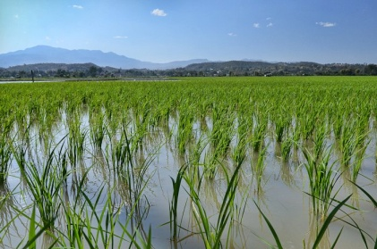](http://www.google.co.il/url?sa=i&rct=j&q=&esrc=s&source=images&cd=&cad=rja&uact=8&ved=0CAcQjRxqFQoTCLKBme-v58YCFUs7FAodVsMMeQ&url=http://moshechiangmai.co.il/%D7%90%D7%95%D7%A8%D7%99-%D7%94%D7%A2%D7%9C%D7%99%D7%95%D7%9F-%D7%AA%D7%9E%D7%95%D7%A0%D7%95%D7%AA/&ei=-a-rVfKgFMv2UNaGs8gH&psig=AFQjCNH4E3JNUy6qHqIbbGkBCGrGw4RAPA&ust=1437401438660398)20

[](http://www.google.co.il/url?sa=i&rct=j&q=&esrc=s&source=images&cd=&cad=rja&uact=8&ved=0CAcQjRxqFQoTCKjKmry158YCFQFpFAod5QMAfg&url=http://www.tipa.co.il/articlePage.asp?articleId%3D1468&ei=2bWrVeh5gdJR5YeA8Ac&bvm=bv.98197061,d.d24&psig=AFQjCNFjJF2VUAhMwTY9wY6O_tZ8Wpbrog&ust=1437402941215015)21

[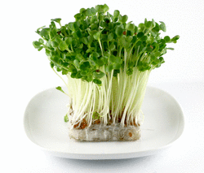](http://www.google.co.il/url?sa=i&rct=j&q=&esrc=s&source=images&cd=&cad=rja&uact=8&ved=0CAcQjRxqFQoTCN2U_uS558YCFYfrFAodrwoBNw&url=http://www.mevashlim.com/Ingredient/4400001.asp&ei=YLqrVd3kEIfXU6-VhLgD&bvm=bv.98197061,d.d24&psig=AFQjCNElgLPsbjXTXNx50lAt8HFah3Gxhg&ust=1437404037153979)22

[](http://www.google.co.il/url?sa=i&rct=j&q=&esrc=s&source=images&cd=&cad=rja&uact=8&ved=0CAcQjRxqFQoTCIGUt8m658YCFcU8FAodSuYBGQ&url=http://recipes.tivoni.co.il/healthy-recipes/84&ei=MrurVYGzOMX5UMrMh8gB&bvm=bv.98197061,d.d24&psig=AFQjCNFpTrtxgpa-2S6CuGfVebgBs397Iw&ust=1437404331937145)23

[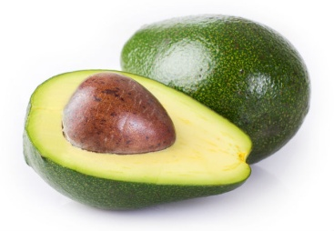](http://www.google.co.il/url?sa=i&rct=j&q=&esrc=s&source=images&cd=&cad=rja&uact=8&ved=0CAcQjRxqFQoTCJD9r42758YCFUdYFAodtEALXg&url=http://saloona.co.il/blog/%D7%94%D7%9E%D7%96%D7%95%D7%A0%D7%95%D7%AA-%D7%94%D7%9B%D7%99-%D7%9E%D7%95%D7%9E%D7%9C%D7%A6%D7%99%D7%9D-%D7%9C%D7%A0%D7%99%D7%A7%D7%95%D7%99-%D7%A8%D7%A2%D7%9C%D7%99%D7%9D/&ei=wburVdCYGcewUbSBrfAF&bvm=bv.98197061,d.d24&psig=AFQjCNEaTCx6XDPo9B5_JVELE-VFprljIQ&ust=1437404387408899)24

[](http://www.google.co.il/url?sa=i&rct=j&q=&esrc=s&source=images&cd=&cad=rja&uact=8&ved=0CAcQjRxqFQoTCIybv7Pk5cYCFULAFAodv2EIVg&url=http://www.kikar.co.il/%D7%94%D7%90%D7%93%D7%9D-%D7%A2%D7%A5-%D7%94%D7%A9%D7%93%D7%94-%D7%A2%D7%A5-%D7%9B%D7%9E%D7%A7%D7%95%D7%A8-%D7%A4%D7%A1%D7%99%D7%9B%D7%95%D7%9C%D7%95%D7%92.html&ei=n9qqVczPLMKAU7_DobAF&bvm=bv.98197061,d.d24&psig=AFQjCNG8pNUU5-fPJ_nmQVjnLjziuGAyoQ&ust=1437346816905045)25

[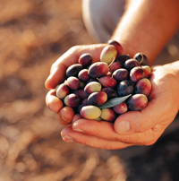](http://www.google.co.il/url?sa=i&rct=j&q=&esrc=s&source=images&cd=&cad=rja&uact=8&ved=0CAcQjRxqFQoTCIKf-ofG58YCFcnAFAodLXIAEw&url=http://www.hashulchan.co.il/?CategoryID%3D59%26ArticleID%3D10357&ei=PserVYKIM8mBU63kgZgB&bvm=bv.98197061,d.d24&psig=AFQjCNFMl1YTMqBd1avovJV400uHoyasdg&ust=1437406849812251)26

[](http://www.google.co.il/url?sa=i&rct=j&q=&esrc=s&source=images&cd=&cad=rja&uact=8&ved=0CAcQjRxqFQoTCJbWmMnJ58YCFcy7FAodEaICBg&url=http://www.mako.co.il/living-architecture/world/Article-d20b9bffc76ef31006.htm&ei=7MqrVZawOsz3UpHEijA&bvm=bv.98197061,d.d24&psig=AFQjCNFsM9R9sIJwepySKtZpQDUCCnVBTw&ust=1437408307130549)27

[](http://www.google.co.il/url?sa=i&rct=j&q=&esrc=s&source=images&cd=&cad=rja&uact=8&ved=0CAcQjRxqFQoTCPK4qLrL58YCFQEfFAod_A4ARQ&url=http://www.chef-lavan.co.il/item/1584&ei=5syrVfKtJoG-UPydgKgE&bvm=bv.98197061,d.d24&psig=AFQjCNE-80v7IWMKk6UE-IWFkdf5HwoPKQ&ust=1437408799359684)28

[](http://www.google.co.il/url?sa=i&rct=j&q=&esrc=s&source=images&cd=&cad=rja&uact=8&ved=0CAcQjRxqFQoTCP6-t-vL58YCFUJrFAodL8YFcQ&url=http://www.calcalist.co.il/marketing/articles/0,7340,L-3607339,00.html&ei=Tc2rVb7kJsLWUa-Ml4gH&bvm=bv.98197061,d.d24&psig=AFQjCNEsW7sH-ZB-bS945R3mkGOtVhzQDg&ust=1437408946810934)29

[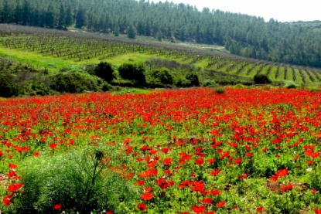](http://www.google.co.il/url?sa=i&rct=j&q=&esrc=s&source=images&cd=&cad=rja&uact=8&ved=0CAcQjRxqFQoTCNHg5M_N58YCFUSzFAod0XkOaw&url=http://photolight.co.il/show_photo/322233&ei=LM-rVdGaIMTmUtHzudgG&bvm=bv.98197061,d.d24&psig=AFQjCNHY2BHsxQxU_bMokEXrOWGKvDRHZg&ust=1437409423697967)30

[](http://www.google.co.il/url?sa=i&rct=j&q=&esrc=s&source=images&cd=&cad=rja&uact=8&ved=0CAcQjRxqFQoTCNnB7LTb58YCFQEyFAodqmMAZQ&url=http://gilisoffer.com/WP/?p%3D45&ei=ot2rVdnoB4HkUKrHgagG&bvm=bv.98197061,d.d24&psig=AFQjCNECAcMZQ-_iNRMU92Bt6KNQwkUtYA&ust=1437413065640900)31

[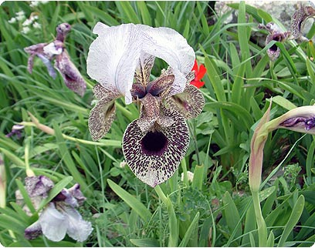](http://www.nrg.co.il/online/55/ART1/550/399.html)32

[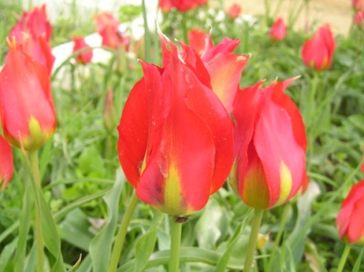](http://www.google.co.il/url?sa=i&rct=j&q=&esrc=s&source=images&cd=&cad=rja&uact=8&ved=0CAcQjRxqFQoTCNCulKnd58YCFcyyFAodJy4Kmw&url=http://www.seedsfromzion.co.il/128163/%D7%A6%D7%91%D7%A2%D7%95%D7%A0%D7%99-%D7%94%D7%94%D7%A8%D7%99%D7%9D&ei=ot-rVdDVHczlUqfcqNgJ&bvm=bv.98197061,d.d24&psig=AFQjCNEYpvo9zKJVdzH-AoKIMq5-VcGILw&ust=1437413652838299)33

[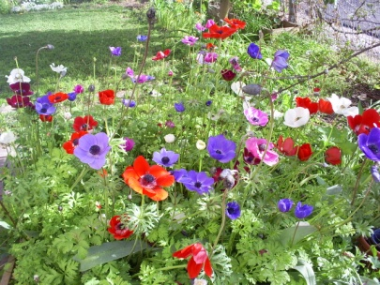](http://www.google.co.il/url?sa=i&rct=j&q=&esrc=s&source=images&cd=&cad=rja&uact=8&ved=0CAcQjRxqFQoTCM-Ogt_e58YCFYTrFAod_dIFww&url=http://www.tapuz.co.il/blog/net/viewentry.aspx?entryId%3D2152405&ei=H-GrVY-DNYTXU_2ll5gM&bvm=bv.98197061,d.d24&psig=AFQjCNH-d8y96iFkHg3hU5OMowGILtR1nA&ust=1437413977114325)34

[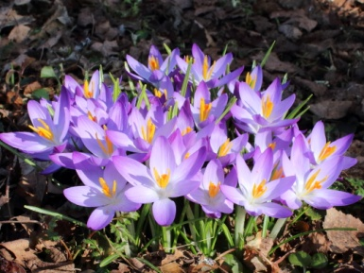](https://www.google.co.il/url?sa=i&rct=j&q=&esrc=s&source=images&cd=&cad=rja&uact=8&ved=0CAcQjRxqFQoTCK3wqIPg58YCFcs3FAodHEoBjw&url=https://he.wikipedia.org/wiki/%D7%AA%D7%91%D7%A0%D7%99%D7%AA:%D7%AA%D7%9E%D7%95%D7%A0%D7%94_%D7%9E%D7%95%D7%9E%D7%9C%D7%A6%D7%AA_16_%D7%91%D7%9E%D7%90%D7%99_2013&ei=eOKrVa3UGsvvUJyUhfgI&bvm=bv.98197061,d.d24&psig=AFQjCNGGaWELOQNDiq3pmYpZLWlotnJwdw&ust=1437414333256663)35

[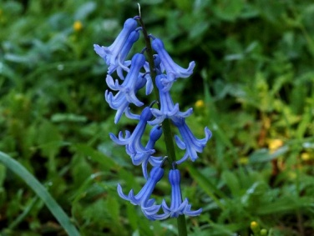](http://www.google.co.il/url?sa=i&rct=j&q=&esrc=s&source=images&cd=&cad=rja&uact=8&ved=0CAcQjRxqFQoTCM33ouTh58YCFYu8FAodZwUDzw&url=http://www.tiuli.com/forum/forum_posts.asp?tid%3D2238&ei=UOSrVc2PDIv5UueKjPgM&bvm=bv.98197061,d.d24&psig=AFQjCNFD-rIMdFTs-cL-pwiUAleooy8JYA&ust=1437414857557532)36

[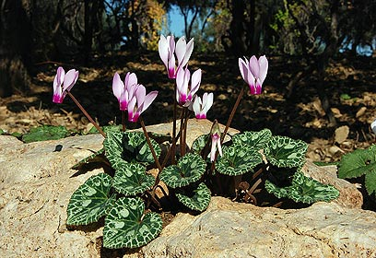](http://www.google.co.il/url?sa=i&rct=j&q=&esrc=s&source=images&cd=&cad=rja&uact=8&ved=0CAcQjRxqFQoTCLyL4NTj58YCFcO0FAod5kwAFA&url=http://www.ynet.co.il/articles/0,7340,L-4032914,00.html&ei=SOarVbzHH8PpUuaZgaAB&bvm=bv.98197061,d.d24&psig=AFQjCNGi1hGtJK9rLh5KqmFFSmKAhkLLJw&ust=1437415221786568)37

[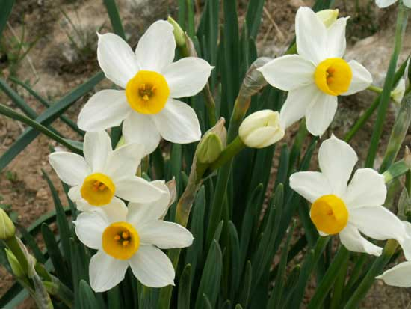](http://www.google.co.il/url?sa=i&rct=j&q=&esrc=s&source=images&cd=&cad=rja&uact=8&ved=0CAcQjRxqFQoTCNWL7PLm58YCFQRdFAodQQ0OTA&url=http://www.tiuli.com/flower_tracks.asp?flower_id%3D77&ei=rOmrVdWFOYS6UcGauOAE&bvm=bv.98197061,d.d24&psig=AFQjCNFlyQcuE0F1swnauUjvWpzju6s3Zg&ust=1437416174792112)38

[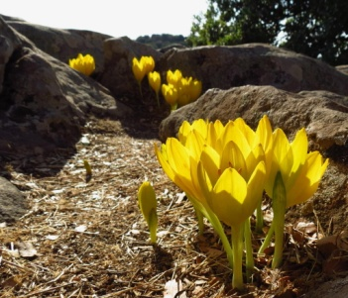](http://www.google.co.il/url?sa=i&rct=j&q=&esrc=s&source=images&cd=&cad=rja&uact=8&ved=0CAcQjRxqFQoTCIbmuern58YCFQFVFAodlZ4JEA&url=http://rotter.net/forum/scoops1/53017.shtml&ei=p-qrVcb2LoGqUZW9poAB&bvm=bv.98197061,d.d24&psig=AFQjCNGNhh65bC6XZ9Hrhv0_tJ0B954JwQ&ust=1437416477162407)39

[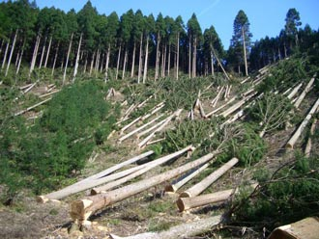](http://www.google.co.il/url?sa=i&rct=j&q=&esrc=s&source=images&cd=&cad=rja&uact=8&ved=0CAcQjRxqFQoTCMyRkozr58YCFQfRFAoddv8K6w&url=http://www.holistica2000.com.ar/Ecologia/ilos-bosques-se-van-por-el-inodoro.html&ei=E-6rVYy8LIeiU_b-q9gO&bvm=bv.98197061,d.d24&psig=AFQjCNGUPFcnOnLuEIZ2yYCBAKwYoPzDOg&ust=1437417333734928)40

[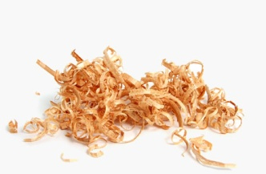](http://www.google.co.il/url?sa=i&rct=j&q=&esrc=s&source=images&cd=&cad=rja&uact=8&ved=0CAcQjRxqFQoTCMvznr_t58YCFcRtFAodk0oENg&url=http://m.calcalist.co.il/article.aspx?guid%3D3513814&ei=l_CrVYvMLsTbUZOVkbAD&bvm=bv.98197061,d.d24&psig=AFQjCNE1jaOovo7gaDU6PAFWd51w_MmTnQ&ust=1437417973504073)41

[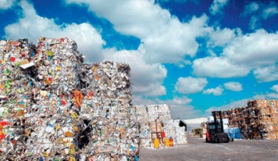](http://www.google.co.il/url?sa=i&rct=j&q=&esrc=s&source=images&cd=&cad=rja&uact=8&ved=0CAcQjRxqFQoTCNfSzI_t58YCFUu1FAod6hUCpA&url=http://www.haaretz.com/print-edition/news/ministry-readies-recycling-law-but-hasn-t-prepared-manufacturers-municipalities-1.368142&ei=M_CrVZftM8vqUuqriKAK&bvm=bv.98197061,d.d24&psig=AFQjCNFNIckBcDfYEY_77p0V51cQo1psKw&ust=1437417649618854)42

[](http://www.google.co.il/url?sa=i&rct=j&q=&esrc=s&source=images&cd=&cad=rja&uact=8&ved=0CAcQjRxqFQoTCKHJr5bw58YCFck9FAodsk8Auw&url=http://treepicturesonline.com/willow_tree_pictures.html&ei=Z_OrVeH5Fcn7ULKfgdgL&bvm=bv.98197061,d.d24&psig=AFQjCNFKorRDLSSBU-TZd8ucnxzMrd0GSw&ust=1437418610015084)43

[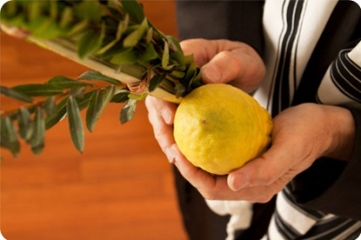](http://www.google.co.il/url?sa=i&rct=j&q=&esrc=s&source=images&cd=&cad=rja&uact=8&ved=0CAcQjRxqFQoTCNTX8orx58YCFUS3FAodWi0BZQ&url=http://www.groupon.co.il/deals/sharon-iw/yehudash/1044083&ei=W_SrVZS-LMTuUtrahKgG&bvm=bv.98197061,d.d24&psig=AFQjCNE83dFRMmGJFryK3Px6gEihlWaY1Q&ust=1437418946697208)44

[](http://www.google.co.il/url?sa=i&rct=j&q=&esrc=s&source=images&cd=&cad=rja&uact=8&ved=0CAcQjRxqFQoTCPCyuPHg58YCFcxWFAod-hQL5A&url=http://www.picshare.co.il/gallery_subjects_heb.asp?cm_id%3D%26cam_id%3D1217&ei=X-OrVbCHF8ytUfqprKAO&bvm=bv.98197061,d.d24&psig=AFQjCNGQlsUtYK11w-7ealbA7rGN31dmGA&ust=1437414559935586)45

[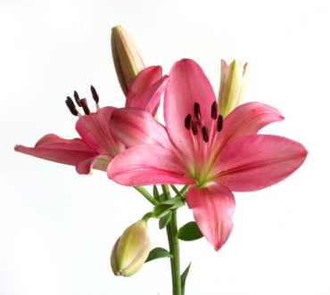](http://www.google.co.il/url?sa=i&rct=j&q=&esrc=s&source=images&cd=&cad=rja&uact=8&ved=0CAcQjRxqFQoTCPuorsDz58YCFYm7FAodmLcCNA&url=http://www.tapuz.co.il/blog/net/viewentry.aspx?entryId%3D2421416&ei=5ParVfumLIn3UpjviqAD&bvm=bv.98197061,d.d24&psig=AFQjCNEmWD2AFfZjp8Vq0XEdPsLiIV12JA&ust=1437419528301435)46

[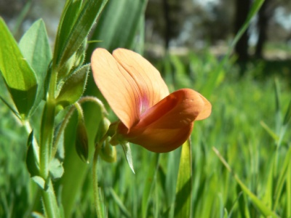](http://www.google.co.il/url?sa=i&rct=j&q=&esrc=s&source=images&cd=&cad=rja&uact=8&ved=0CAcQjRxqFQoTCKjI0ZD058YCFYdrFAod1WMAUQ&url=http://www.tapuz.co.il/blog/net/viewentry.aspx?entryId%3D2574899&ei=jferVejNBIfXUdXHgYgF&bvm=bv.98197061,d.d24&psig=AFQjCNFIs0ncHqN9LzWbBl7JNb9Z70avow&ust=1437419695522879)47

[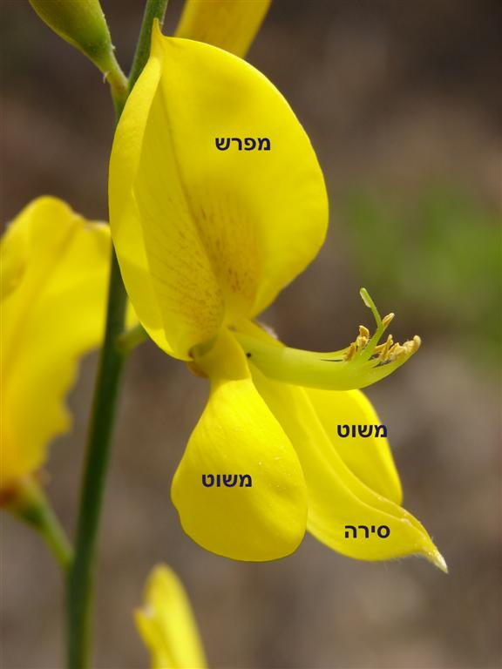](http://www.google.co.il/url?sa=i&rct=j&q=&esrc=s&source=images&cd=&cad=rja&uact=8&ved=0CAcQjRxqFQoTCK2FgPbz58YCFYg_FAodijQHWQ&url=http://daf-yomi.com/DYItemDetails.aspx?itemId%3D3173&ei=VferVe2GDYj_UIrpnMgF&bvm=bv.98197061,d.d24&psig=AFQjCNFIs0ncHqN9LzWbBl7JNb9Z70avow&ust=1437419695522879)48 (לעשות את המדבקה לאורך)