בעזהי"ת

[](http://www.google.co.il/url?sa=i&rct=j&q=&esrc=s&source=images&cd=&cad=rja&uact=8&ved=0CAcQjRw&url=http://www.clalit.co.il/he/lifestyle/nutrition/pages/prepare_for_ten.aspx&ei=Fz53VaeqB8GysQGalYCwDw&psig=AFQjCNEdd6gl_btEhjkj4mEPVPcLdbwzKg&ust=1433964355267173)1

[](http://www.google.co.il/url?sa=i&rct=j&q=&esrc=s&source=images&cd=&cad=rja&uact=8&ved=0CAcQjRw&url=http://www.eatwell.co.il/?CategoryID=392&ArticleID=4349&ei=_m6RVf-ZNsG3sQHz_L-YAQ&bvm=bv.96783405,d.bGg&psig=AFQjCNFwyKGJyA18mXMJorW9XPsj92IH3g&ust=1435680771035238)2

[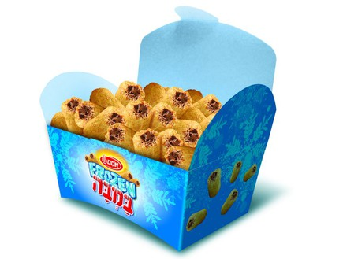](http://www.google.co.il/url?sa=i&rct=j&q=&esrc=s&source=images&cd=&cad=rja&uact=8&ved=0CAcQjRw&url=http://www.mako.co.il/food-consumer/Article-0a2db82dd4d0841006.htm&ei=A4iaVarEBcKw-AGHl5ywCg&bvm=bv.96952980,d.cWw&psig=AFQjCNE2CrFHFFR5CP97mmNkqjKDywe2Wg&ust=1436277099143380)3

[](http://www.greentec.co.il/65561/%D7%9E%D7%92%D7%A9-%D7%97%D7%9C%D7%95%D7%AA-%D7%94%D7%A4%D7%9C%D7%90-1)4

[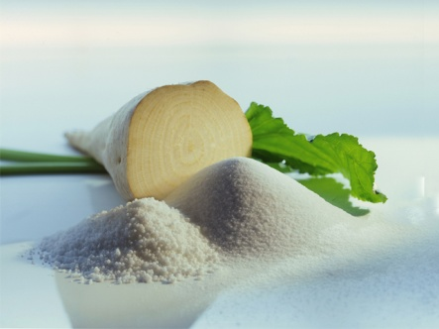](http://www.google.co.il/url?sa=i&rct=j&q=&esrc=s&source=images&cd=&cad=rja&uact=8&ved=0CAcQjRw&url=http://contaconect.ro/econ/agricultura-econ/penalizare-pentru-cota-de-zahar/&ei=kCd3VeXuHMypsAH4hoGIAg&bvm=bv.95039771,d.bGg&psig=AFQjCNHIgZRa_fdhGH-JjXpdkqn8zpsw_w&ust=1433958663774395)5

[](http://www.google.co.il/url?sa=i&rct=j&q=&esrc=s&source=images&cd=&cad=rja&uact=8&ved=0CAcQjRw&url=http://www.oogio.net/pinata_cake&ei=PjZ3VdaYDMGOsAGpoInoCg&bvm=bv.95039771,d.bGg&psig=AFQjCNG7l8RHuXZPcgMfTjXgYS_H5azHwA&ust=1433962334554988)6

[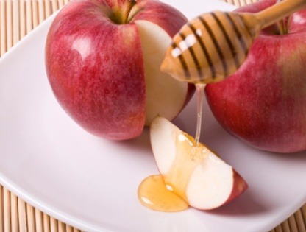](http://www.google.co.il/url?sa=i&rct=j&q=&esrc=s&source=images&cd=&cad=rja&uact=8&ved=0CAcQjRw&url=http://www.mako.co.il/spirituality-popular_culture/Article-ff10fc220b0c931006.htm&ei=FQyPVbO3Oc3y7AaSl634Dg&bvm=bv.96783405,d.bGg&psig=AFQjCNH3TK2R_DUOm7ZlwREsZ2smurVMqQ&ust=1435524451057063)7

*[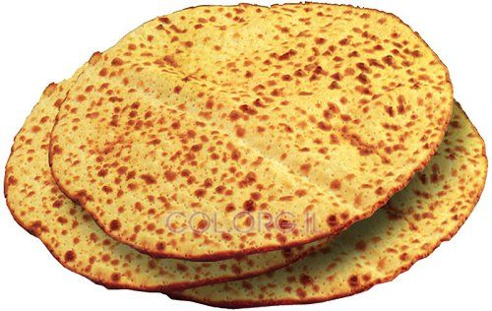](http://www.google.co.il/url?sa=i&rct=j&q=&esrc=s&source=images&cd=&cad=rja&uact=8&ved=0CAcQjRw&url=http://www.col.org.il/%D7%97%D7%93%D7%A9%D7%95%D7%AA_%D7%97%D7%91%D7%93_%D7%9E%D7%A6%D7%95%D7%AA_%D7%A2%D7%91%D7%95%D7%93%D7%AA_%D7%99%D7%93_%D7%93%D7%95%D7%A7%D7%90_%D7%9E%D7%93%D7%95%D7%A2_10997.html&ei=JwuPVeXHPMit7AbO8bGoDg&bvm=bv.96783405,d.bGg&psig=AFQjCNHKzsiVhrki9WlRiAxGqFyxANeYrw&ust=1435524257053629)8*

[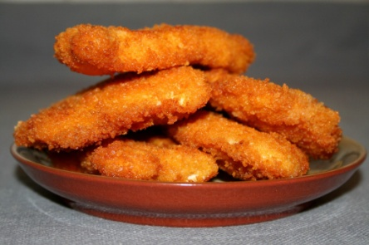](http://www.google.co.il/url?sa=i&rct=j&q=&esrc=s&source=images&cd=&cad=rja&uact=8&ved=0CAcQjRw&url=http://www.tavshilim.co.il/archives/recipe-items/%D7%A9%D7%A0%D7%99%D7%A6%D7%9C-%D7%A2%D7%95%D7%A3&ei=-i1rVbKLNouqsQGM3ICACg&psig=AFQjCNELl9qCE8m4NcMZ2zEM6UIK-IP7RQ&ust=1433173706684022)9

[](http://www.google.co.il/url?sa=i&rct=j&q=&esrc=s&source=images&cd=&cad=rja&uact=8&ved=0CAcQjRw&url=http://rotter.name/nor/party/10466.shtml&ei=BTh3VeP1FoezswGd0IGICQ&bvm=bv.95039771,d.bGg&psig=AFQjCNEGgQztnWrfGwvel8504K2rkoxrhQ&ust=1433962725056636)10

[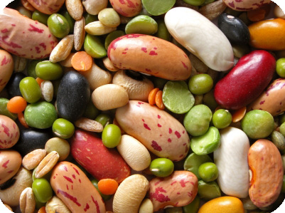](http://www.google.co.il/url?sa=i&rct=j&q=&esrc=s&source=images&cd=&cad=rja&uact=8&ved=0CAcQjRw&url=http://www.pickpook.org/2013/04/13/%D7%A7%D7%98%D7%A0%D7%99%D7%95%D7%AA-%D7%91%D7%A4%D7%A1%D7%97-%E2%80%93-%D7%9C%D7%95%D7%92%D7%99%D7%A7%D7%94-%D7%9E%D7%A9%D7%A4%D7%98%D7%99%D7%AA-%D7%9B%D7%9E%D7%92%D7%93%D7%99%D7%A8%D7%94-%D7%96/&ei=AS9rVYCqFcyRsgHfu4OYAQ&psig=AFQjCNEJVmN8oSCorPtbOTTU5BgiJt5Wlg&ust=1433174064613186)11

[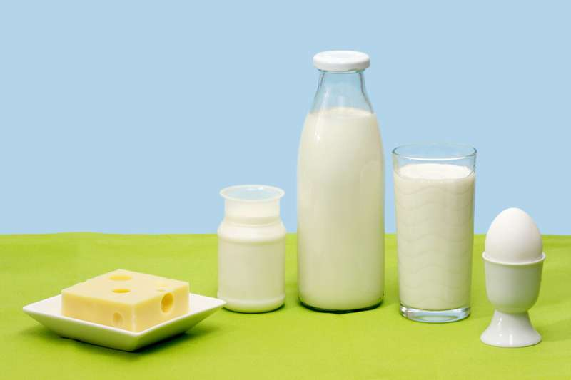](http://www.google.co.il/url?sa=i&rct=j&q=&esrc=s&source=images&cd=&cad=rja&uact=8&ved=0CAcQjRw&url=http://www.camoni.co.il/?idr=400&p=4826&ei=8y13Vc_CKMiNsAHX_ZmgAQ&v6u=https://s-v6exp1-ds.metric.gstatic.com/gen_204?ip=5.102.254.211&ts=1433873876005030&auth=ywlbmn2kaktc7m5u6kvyzpxxc3fec6v7&rndm=0.25966593609096583&v6s=2&v6t=37739&bvm=bv.95039771,d.bGg&psig=AFQjCNHz0zep93H1SPKyXBq4r2or0UN5eA&ust=1433960275950122)12

[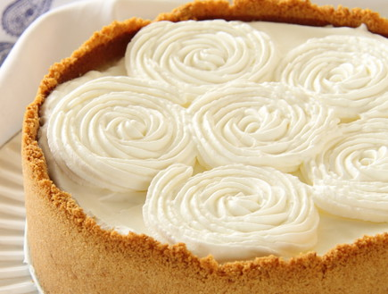](http://www.google.co.il/url?sa=i&rct=j&q=&esrc=s&source=images&cd=&cad=rja&uact=8&ved=0CAcQjRw&url=http://www.mako.co.il/food-shavuot/Recipe-f302a97b4f95e31006.htm&ei=DY2aVfRWgeb4AbKtr_AG&bvm=bv.96952980,d.cWw&psig=AFQjCNG-OUj0oC4FAei0flwPlKRFuP4_Hg&ust=1436278357589938)13

[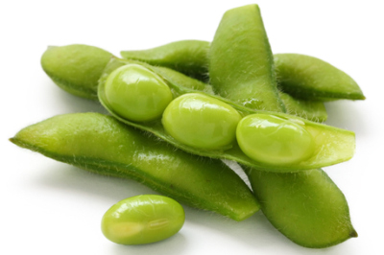](http://www.google.co.il/url?sa=i&rct=j&q=&esrc=s&source=images&cd=&cad=rja&uact=8&ved=0CAcQjRw&url=http://www.motke.co.il/index.php?idr=400&p=2008806&ei=IZWaVdvrNcri-QGRtoHACA&bvm=bv.96952980,d.cWw&psig=AFQjCNFwaaTMgFyDXiGMOQ8X3YAgnaIKlA&ust=1436280452008586)14

[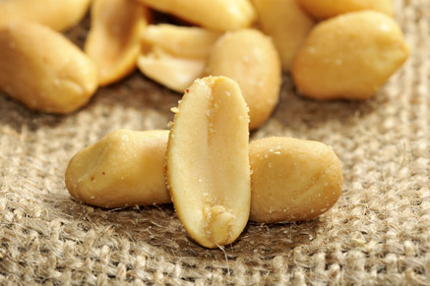](http://www.google.co.il/url?sa=i&rct=j&q=&esrc=s&source=images&cd=&cad=rja&uact=8&ved=0CAcQjRw&url=http://www.foodsdictionary.co.il/articles/879&ei=1y5rVeqUHsK6swG044LwDQ&psig=AFQjCNEJVmN8oSCorPtbOTTU5BgiJt5Wlg&ust=1433174064613186)15

[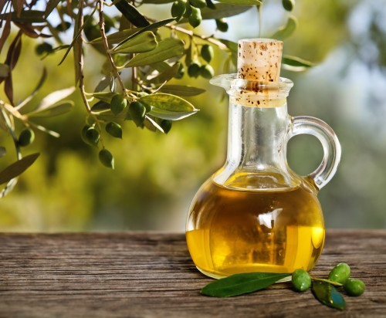](http://www.google.co.il/url?sa=i&rct=j&q=&esrc=s&source=images&cd=&cad=rja&uact=8&ved=0CAcQjRw&url=http://www.hayadan.org.il/meditranian-mystery-2609135&ei=Vj13VZ6cNcK9swHn0YGIDg&psig=AFQjCNGPvRLVF2SeZAhSmXkXil-p701wzA&ust=1433964227594156)16

[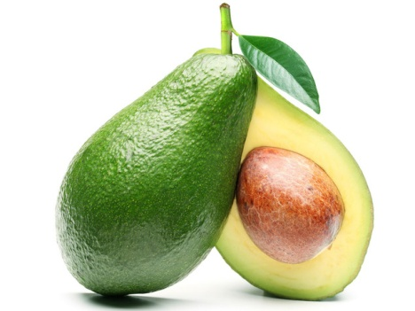](http://www.google.co.il/url?sa=i&rct=j&q=&esrc=s&source=images&cd=&cad=rja&uact=8&ved=0CAcQjRw&url=http://healthy.walla.co.il/item/2787286&ei=qylrVfiMNomXsgG7q4CYCg&bvm=bv.94455598,d.bGg&psig=AFQjCNH0BUiVB7PXDVn_0cU8WfvJYUBtsQ&ust=1433172610300459)17

[](http://bekosher.co.il/wp-content/uploads/2012/02/iStock_000014393094XSmall.jpg)18

19[](http://www.google.co.il/url?sa=i&rct=j&q=&esrc=s&source=images&cd=&cad=rja&uact=8&ved=0CAcQjRxqFQoTCP2M4o-8hcYCFcHeLAodfXgA0w&url=http://www.hdhintergrundbilder.com/2014/11/hd-blumen-hintergrundbilder.html&ei=fFt4Vf3eHsG9swH98IGYDQ&bvm=bv.95039771,d.bGg&psig=AFQjCNHCF-OVtVhkryLLR_1qHA7H5RAqZA&ust=1434037403937466)

[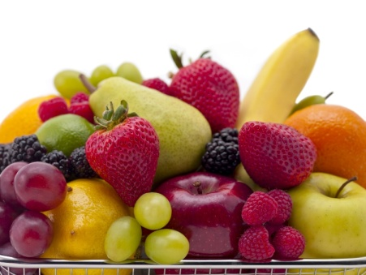](http://www.agogo.co.il/foodb/)20

[](http://www.google.co.il/url?sa=i&rct=j&q=&esrc=s&source=images&cd=&cad=rja&uact=8&ved=0CAcQjRw&url=http://www.fxp.co.il/showthread.php?t=4748349&ei=WTJrVZrNNYqKsgHy1oHwCQ&psig=AFQjCNFu4YDS6oz0AFQ8HF8uuL0-BnYZ-Q&ust=1433174971194243)21

[](http://www.google.co.il/url?sa=i&rct=j&q=&esrc=s&source=images&cd=&cad=rja&uact=8&ved=0CAcQjRw&url=http://www.ynet.co.il/articles/0,7340,L-4587500,00.html&ei=PSN3VdzoO4qSsgHOwIKoCQ&bvm=bv.95039771,d.bGg&psig=AFQjCNGpXskM1iNG-EWsv6maB2Q-foanWQ&ust=1433957532758065)22

[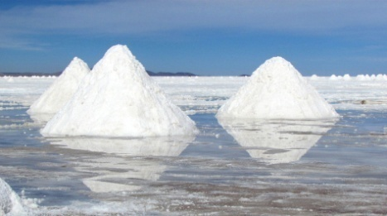](http://www.google.co.il/url?sa=i&rct=j&q=&esrc=s&source=images&cd=&cad=rja&uact=8&ved=0CAcQjRw&url=http://www.photolight.co.il/show_photo/687842&ei=Fhx3VdSJIoGXsAGh26nQCQ&bvm=bv.95039771,d.bGg&psig=AFQjCNFEf4532yZkL5SQhGbwiNo3GQiE5Q&ust=1433955719867580)23

[](http://www.google.co.il/url?sa=i&rct=j&q=&esrc=s&source=images&cd=&cad=rja&uact=8&ved=0CAcQjRxqFQoTCJWW-aakj8YCFUUILAodXasKTw&url=http://www.fotosearch.co.il/CSP563/k5630787/&ei=sIB9VZX-AsWQsAHd1qr4BA&bvm=bv.95515949,d.bGg&psig=AFQjCNH2GfpHfl_HCTwcubFo0qVaATvfVw&ust=1434374688974357)24

[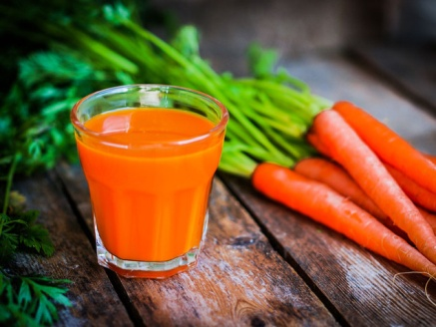](http://www.google.co.il/url?sa=i&rct=j&q=&esrc=s&source=images&cd=&cad=rja&uact=8&ved=0CAcQjRw&url=http://healthy.walla.co.il/item/2830536&ei=3StrVewxiaKyAYX-gNAM&psig=AFQjCNH0BUiVB7PXDVn_0cU8WfvJYUBtsQ&ust=1433172610300459)25

[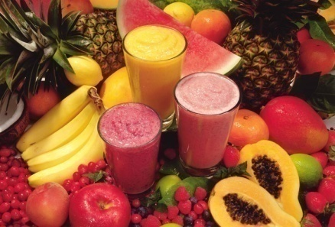](http://www.google.co.il/url?sa=i&rct=j&q=&esrc=s&source=images&cd=&cad=rja&uact=8&ved=0CAcQjRw&url=http://xnet.ynet.co.il/health/articles/0,14713,L-3094439,00.html&ei=TUB3VfayHsKyswGWqJaYCw&psig=AFQjCNFiXC-1zsIXfTTuhrerjTbesSpqCQ&ust=1433964946139701)26

[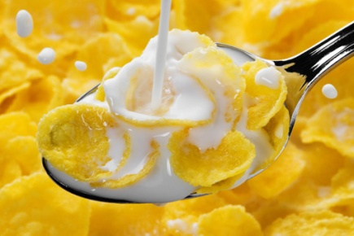](http://www.google.co.il/url?sa=i&rct=j&q=&esrc=s&source=images&cd=&cad=rja&uact=8&ved=0CAcQjRw&url=http://www.tostudy.co.il/maamar.aspx?id=4338&ei=XS53VbnvFYqosAGZ3YD4CA&bvm=bv.95039771,d.bGg&psig=AFQjCNHz0zep93H1SPKyXBq4r2or0UN5eA&ust=1433960275950122)27

[](http://www.google.co.il/url?sa=i&rct=j&q=&esrc=s&source=images&cd=&cad=rja&uact=8&ved=0CAcQjRw&url=http://www.lunch-time.co.il/kids-lunch/&ei=Wz53Vay8L8izswGi34DgCw&psig=AFQjCNEdd6gl_btEhjkj4mEPVPcLdbwzKg&ust=1433964355267173)28

[](http://www.google.co.il/url?sa=i&rct=j&q=&esrc=s&source=images&cd=&cad=rja&uact=8&ved=0CAcQjRw&url=http://www.2b-bari.co.il/%D7%9E%D7%90%D7%9B%D7%9C-%D7%93%D7%99%D7%90%D7%98%D7%98%D7%99-%D7%98%D7%A2%D7%99%D7%9D/&ei=YzR3Ve7ROcqgsAGGl6vgDA&bvm=bv.95039771,d.bGg&psig=AFQjCNEK1_hkm_Km3sH3hstQeGl0J2xqxg&ust=1433961949568367)29

[](http://www.google.co.il/url?sa=i&rct=j&q=&esrc=s&source=images&cd=&cad=rja&uact=8&ved=0CAcQjRw&url=http://www.hamishpacha.co.il/index.php?dir=site&page=articles&op=item&cs=3276&ei=NquCVYb-EYmxsAGhmo34Cw&bvm=bv.96041959,d.bGg&psig=AFQjCNE_lVKFpWmaiC-akofDrlGLWmrX-w&ust=1434713255058137)30

[](http://www.google.co.il/url?sa=i&rct=j&q=&esrc=s&source=images&cd=&cad=rja&uact=8&ved=0CAcQjRw&url=http://bioagros.gr/el/blog/-typoi-diatrofis-n4&ei=hiKZVdHmAcHt-AGkupiwBw&bvm=bv.96952980,d.cWw&psig=AFQjCNGw7_vpBMxBYh1_qBZbYH7DIRrwuw&ust=1436185575272829)31

[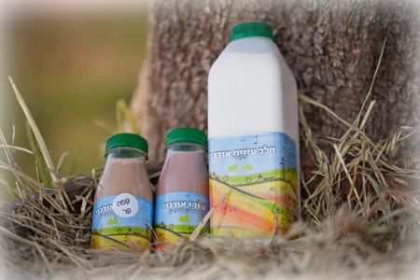](http://www.givotolam.co.il/232966/%D7%9E%D7%A9%D7%A7%D7%90%D7%95%D7%AA-%D7%97%D7%9C%D7%91)32

[](http://www.google.co.il/url?sa=i&rct=j&q=&esrc=s&source=images&cd=&cad=rja&uact=8&ved=0CAcQjRxqFQoTCICswIDWj8YCFYRYLAodW6oFew&url=http://www.maornatan.co.il/219298/%D7%A1%D7%93%D7%A0%D7%AA-%D7%98%D7%A2%D7%99%D7%9E%D7%95%D7%AA-%D7%99%D7%99%D7%9F&ei=zbR9VcCRDISxsQHb1JbYBw&bvm=bv.95515949,d.bGg&psig=AFQjCNGAgIWJrq6lJzR8ZDSJcDU92AgS4A&ust=1434388024390135)33

[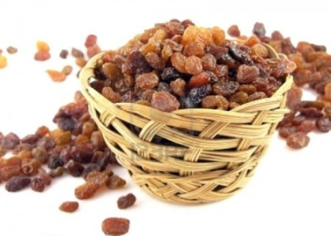](http://www.google.co.il/url?sa=i&rct=j&q=&esrc=s&source=images&cd=&cad=rja&uact=8&ved=0CAcQjRw&url=http://www.foodnculture.com/lets-enjoy-the-feasting-of-the-festive-season/&ei=RzN3Vcr9GMG-sgGdo4nADw&psig=AFQjCNG_JIZRl_kpGnDLjYqTtFq4_w2uuQ&ust=1433961663987742)34

[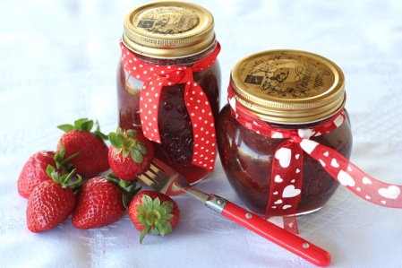](http://www.google.co.il/url?sa=i&rct=j&q=&esrc=s&source=images&cd=&cad=rja&uact=8&ved=0CAcQjRw&url=http://xnet.ynet.co.il/food/articles/0,14567,L-3099375,00.html&ei=zDF3VentLYOusQGUiIOICQ&psig=AFQjCNHW-z88nBhiUu1jBu-SAKJhrUBFag&ust=1433961284470143)35

[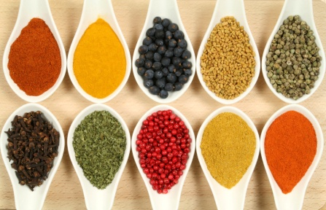](http://www.google.co.il/url?sa=i&rct=j&q=&esrc=s&source=images&cd=&cad=rja&uact=8&ved=0CAcQjRw&url=http://www.naamaspice.com/Articles_add.asp&ei=ejacVb21HIrg-QGzj7Jg&bvm=bv.96952980,d.cWw&psig=AFQjCNH4yXHNxpqGz29pcQPGvRVVqKtRTQ&ust=1436387282184784)36

[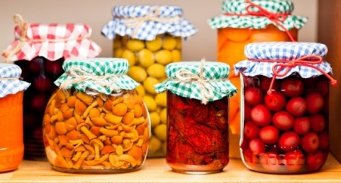](http://www.google.co.il/url?sa=i&rct=j&q=&esrc=s&source=images&cd=&cad=rja&uact=8&ved=0CAcQjRw&url=http://www.moldova.org/%D0%B2-%D1%80%D0%BE%D1%81%D1%81%D0%B8%D0%B8-%D0%B7%D0%B0%D0%BF%D1%80%D0%B5%D1%82%D0%B8%D0%BB%D0%B8-%D0%BA%D0%BE%D0%BD%D1%81%D0%B5%D1%80%D0%B2%D0%B8%D1%80%D0%BE%D0%B2%D0%B0%D0%BD%D0%BD%D1%8B%D0%B5/&ei=2zacVdbnD4LX-QGPz6HYBw&bvm=bv.96952980,d.cWw&psig=AFQjCNG31b23ICIQQW9mo-M7t6txg4GKOw&ust=1436387405657705)37

[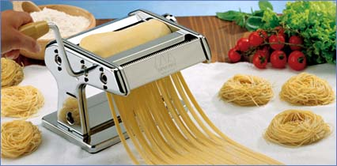](http://www.google.co.il/url?sa=i&rct=j&q=&esrc=s&source=images&cd=&cad=rja&uact=8&ved=0CAcQjRw&url=http://www.kleibait.com/?page=product&id=1424&ei=4jecVdmzJsLk-AGLorKoBA&bvm=bv.96952980,d.cWw&psig=AFQjCNFMhNaQTKmIBP51QtSacv64EPX-Gg&ust=1436387652621766)38

[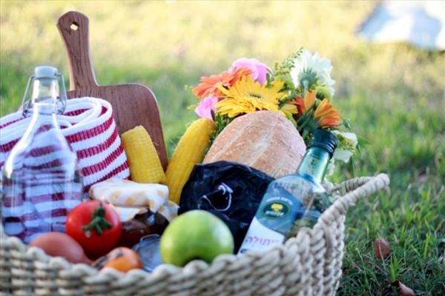](http://www.google.co.il/url?sa=i&rct=j&q=&esrc=s&source=images&cd=&cad=rja&uact=8&ved=0CAcQjRw&url=http://modaland.co.il/Articals/ArticalForm.aspx?ArticalID=418&ei=qc6aVaD9K4bu-QHZqai4Bw&bvm=bv.96952980,d.cWw&psig=AFQjCNEW0L8QApnVZIWombhL9_HrFUSAMg&ust=1436295152567455)39

[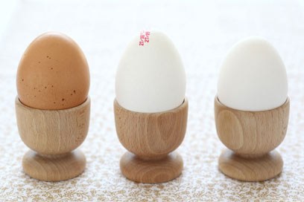](http://www.google.co.il/url?sa=i&rct=j&q=&esrc=s&source=images&cd=&cad=rja&uact=8&ved=0CAcQjRw&url=http://www.ynet.co.il/articles/0,7340,L-3939771,00.html&ei=uh53VbO5J8m3swGql6WYAg&bvm=bv.95039771,d.bGg&psig=AFQjCNFOHIVgBbMAWg3Fd6fwMqwSDOcpbw&ust=1433956397840293)40

[](http://www.google.co.il/url?sa=i&rct=j&q=&esrc=s&source=images&cd=&cad=rja&uact=8&ved=0CAcQjRw&url=http://www.1mother.net/index.php/%D7%91%D7%A2%D7%A7%D7%91%D7%95%D7%AA%20%D7%9E%D7%A6%D7%91%D7%94%20%D7%94%D7%A7%D7%A9%D7%94%20%D7%A9%D7%9C%20%D7%AA%D7%99%D7%A0%D7%95%D7%A7%D7%AA%20%D7%9C%D7%90%D7%97%D7%A8%20%D7%A9%D7%94%D7%95%D7%A9%D7%90%D7%A8%D7%94%20%D7%91%D7%A8%D7%9B%D7%91:/article/4708&ei=nJ-CVf6TAYmgsAHrs6LQBg&bvm=bv.96041959,d.bGg&psig=AFQjCNHcc5uh4eUx-JikqINZQTJRGMTMGQ&ust=1434710257251423)41

[](http://www.google.co.il/url?sa=i&rct=j&q=&esrc=s&source=images&cd=&cad=rja&uact=8&ved=0CAcQjRw&url=http://www.foodsdictionary.co.il/articles/143&ei=haOCVaHMHYKqsgGrza6oAg&bvm=bv.96041959,d.bGg&psig=AFQjCNEASd0TTRnAh683XTF559-emLbzFg&ust=1434711249682265)42

[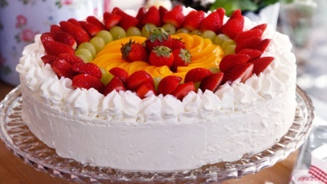](http://www.google.co.il/url?sa=i&rct=j&q=&esrc=s&source=images&cd=&cad=rja&uact=8&ved=0CAcQjRw&url=http://food.walla.co.il/recipe/649932&ei=gCecVcScFoby-QGUx7vIDA&bvm=bv.96952980,d.cWw&psig=AFQjCNH7Y7II5daVjYLfFdPqjNAGHPFnOg&ust=1436383467164918)43

[](http://www.google.co.il/url?sa=i&rct=j&q=&esrc=s&source=images&cd=&cad=rja&uact=8&ved=0CAcQjRxqFQoTCNqanq_Cj8YCFQoULAodAVUAwQ&url=http://food.nana10.co.il/Article/?ArticleID=941033&ei=NqB9VdqnHoqosAGBqoGIDA&bvm=bv.95515949,d.bGg&psig=AFQjCNH0EdTRUlXwC0zKYDD-0QCZP3Hy0A&ust=1434382745513288)44

[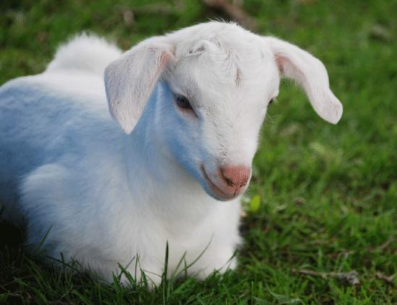](http://www.google.co.il/url?sa=i&rct=j&q=&esrc=s&source=images&cd=&cad=rja&uact=8&ved=0CAcQjRw&url=http://www.motherearthnews.com/homesteading-and-livestock/available-experienced-baby-goat-sitters.aspx&ei=jC2cVcm4GIy5-QGMpo2IDA&bvm=bv.96952980,d.cWw&psig=AFQjCNHmb5rGntoXU6uOUrDeW--lcfYejQ&ust=1436384973171494)45

[](http://www.google.co.il/url?sa=i&rct=j&q=&esrc=s&source=images&cd=&cad=rja&uact=8&ved=0CAcQjRw&url=http://www.moshiach.ru/FAQ/yomtov/8686.html&ei=XhCPVeGwMeu67gbug6TwCg&bvm=bv.96783405,d.bGg&psig=AFQjCNE7oGrnqV9doRag6GVxBJ6Hz0rMyg&ust=1435525575201535)46

[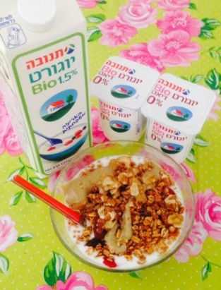](http://www.google.co.il/url?sa=i&rct=j&q=&esrc=s&source=images&cd=&cad=rja&uact=8&ved=0CAcQjRw&url=http://www.findthewoman.co.il/?page_id=4269&ei=IihrVcTUKYaSsgHw4YCQAw&bvm=bv.94455598,d.bGg&psig=AFQjCNGeEq8mzvwUqvAjJVwH1SnuITQqdg&ust=1433172207725971)47

[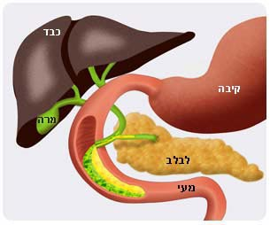](http://www.google.co.il/url?sa=i&rct=j&q=&esrc=s&source=images&cd=&cad=rja&uact=8&ved=0CAcQjRw&url=http://science.cet.ac.il/science/energy/energy4.asp&ei=fzBrVeCpKMyKsAGAgoGABw&psig=AFQjCNFuO1lLdVuRbg-j10v_9Mhrmr6f0A&ust=1433174485207988)48