[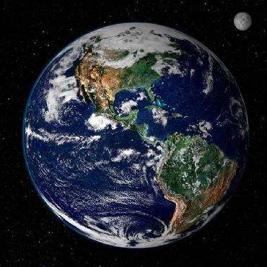](http://www.google.co.il/url?sa=i&rct=j&q=&esrc=s&source=images&cd=&cad=rja&uact=8&ved=0CAcQjRxqFQoTCKHFic7jsMgCFUu2FAodrFQKYQ&url=http://eureka.org.il/item/23262/%D7%9E%D7%94-%D7%94%D7%94%D7%91%D7%93%D7%9C%D7%99%D7%9D-%D7%91%D7%99%D7%9F-%D7%94%D7%A7%D7%95%D7%98%D7%91-%D7%94%D7%A6%D7%A4%D7%95%D7%A0%D7%99-%D7%9C%D7%93%D7%A8%D7%95%D7%9E%D7%99&bvm=bv.104615367,d.d24&psig=AFQjCNGbUiv5_DxwaRCuopSUYR6ub__Qrw&ust=1444321628331820)1

[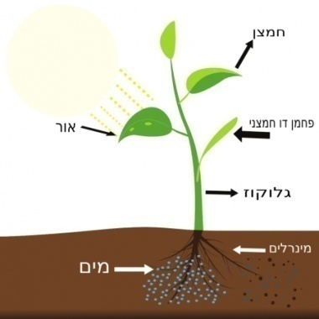](http://www.google.co.il/url?sa=i&rct=j&q=&esrc=s&source=images&cd=&cad=rja&uact=8&ved=0CAcQjRxqFQoTCI-_l66hlcgCFUx_GgodWwoC7g&url=http://israplant.com/index.php?n=2691&psig=AFQjCNFnOpAhsx4oF5DYB7jn7Pfw2ypC4Q&ust=1443376125513001)2

[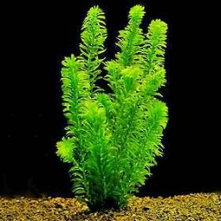](http://www.google.co.il/url?sa=i&rct=j&q=&esrc=s&source=images&cd=&cad=rja&uact=8&ved=0CAcQjRxqFQoTCLP5g7DIusgCFcLJFAodhhEH6w&url=http://www.ofra-aqua.co.il/category/oxidizing&psig=AFQjCNEyy7V7m0yQQmdfxEY1ykrY0qHfKA&ust=1444657943521089)3

[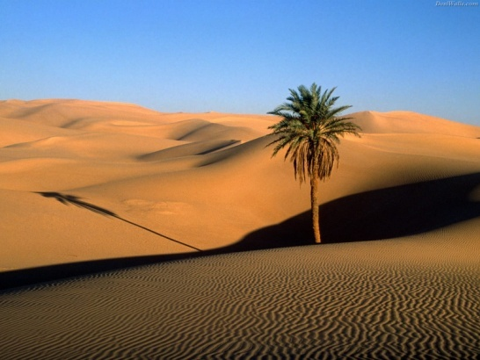](http://www.google.co.il/url?sa=i&rct=j&q=&esrc=s&source=images&cd=&cad=rja&uact=8&ved=0CAcQjRxqFQoTCJLly_nisMgCFYPDFAod3XkL2A&url=http://www.fxp.co.il/showthread.php?t=15128029&psig=AFQjCNGrefl12UGwtu99J6GSISObicDD8Q&ust=1444321469095220)4

[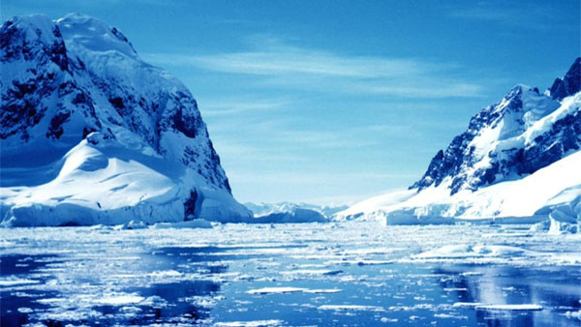](http://www.google.co.il/url?sa=i&rct=j&q=&esrc=s&source=images&cd=&cad=rja&uact=8&ved=0CAcQjRxqFQoTCM6zsdzksMgCFQRVGgodbNsANA&url=http://www.iopanel.net/%D7%A8%D7%95%D7%A6%D7%99%D7%9D-%D7%9C%D7%91%D7%A7%D7%A8-%D7%91%D7%90%D7%A0%D7%98%D7%A8%D7%98%D7%99%D7%A7%D7%94-%D7%A2%D7%9B%D7%A9%D7%99%D7%95-%D7%AA%D7%95%D7%9B%D7%9C%D7%95-%D7%9C%D7%A2%D7%A9%D7%95/&bvm=bv.104615367,d.d24&psig=AFQjCNEyRtl-OWbcRqOHROBTS0guGzXk7Q&ust=1444321813989119)5

[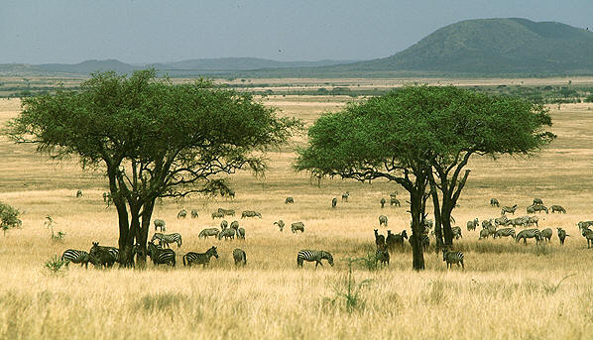](http://www.google.co.il/url?sa=i&rct=j&q=&esrc=s&source=images&cd=&cad=rja&uact=8&ved=0CAcQjRxqFQoTCOv_-cLqsMgCFQtXFAodE30DEQ&url=http://www.fxp.co.il/showthread.php?t=8876986&bvm=bv.104615367,d.d24&psig=AFQjCNGe3dT_obgjSZJUnx43PhgHtEbA-Q&ust=1444323492999952)6

[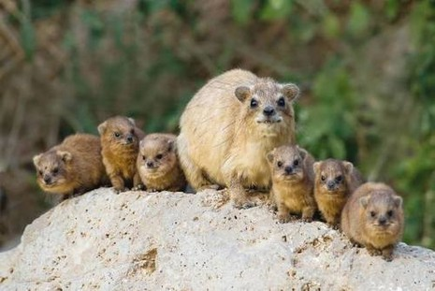](http://caspitweb.com/blog/?p=729)7

[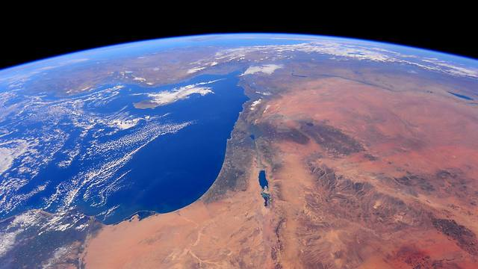](http://www.google.co.il/url?sa=i&rct=j&q=&esrc=s&source=images&cd=&cad=rja&uact=8&ved=0CAcQjRxqFQoTCJ-DgZHusMgCFUZvFAodtFQFmg&url=http://www.i24news.tv/en/news/israel/55776-141227-view-of-israel-from-outer-space&bvm=bv.104615367,d.d24&psig=AFQjCNGhNDnc6FrQnl_uhNx6yC8q5FP51Q&ust=1444324314376961)8

[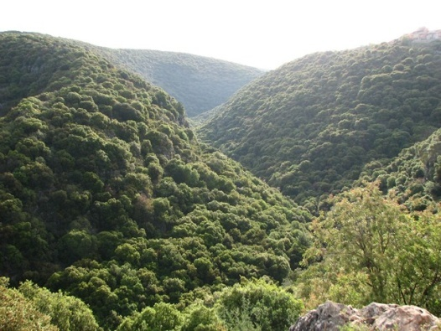](http://www.google.co.il/url?sa=i&rct=j&q=&esrc=s&source=images&cd=&cad=rja&uact=8&ved=0CAcQjRxqFQoTCJec8dfwsMgCFUQ-FAodvnABvw&url=http://www.inature.info/wiki/%D7%A9%D7%9E%D7%95%D7%A8%D7%AA_%D7%94%D7%A8_%D7%A1%D7%A0%D7%94&bvm=bv.104615367,d.d24&psig=AFQjCNH7w69pLouS1ybhE3P1CL6hLFdpMQ&ust=1444325033396793)9

[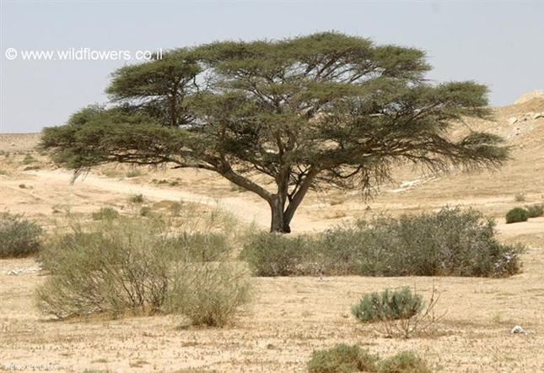](http://www.google.co.il/url?sa=i&rct=j&q=&esrc=s&source=images&cd=&cad=rja&uact=8&ved=0CAcQjRxqFQoTCKSVyN7xsMgCFca0FAod0ngPww&url=http://daf-yomi.com/DYItemDetails.aspx?itemId=25769&bvm=bv.104615367,d.d24&psig=AFQjCNE2oU7sFVmAlfQS6wRduQtRVmzzmA&ust=1444325309750776)10

[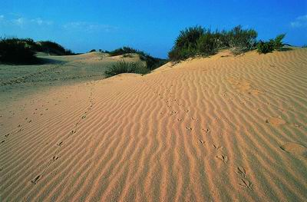](http://www.google.co.il/url?sa=i&rct=j&q=&esrc=s&source=images&cd=&cad=rja&uact=8&ved=0CAcQjRxqFQoTCIOB-qPysMgCFUI3FAodx5sOUA&url=http://addyourpoint.com/view_point.php?id=3165567&bvm=bv.104615367,d.d24&psig=AFQjCNHN07UYS1Jh0ON3x_m6EunayL68oQ&ust=1444325552206197)11

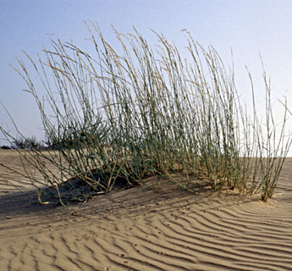12

[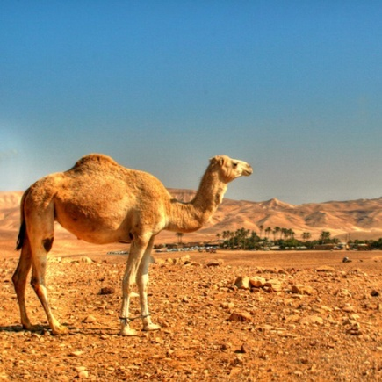](http://www.google.co.il/url?sa=i&rct=j&q=&esrc=s&source=images&cd=&cad=rja&uact=8&ved=0CAcQjRxqFQoTCJqwhen5sMgCFQMKGgodXuwMXw&url=http://www.marmelada.co.il/27072/%D7%91%D7%A7%D7%A8%D7%95%D7%91-%D7%90%D7%A6%D7%9C%D7%9B%D7%9D/&psig=AFQjCNHjOJ11xeqSGYOJu4R2x-8Elgw8Jg&ust=1444327610615185)13

[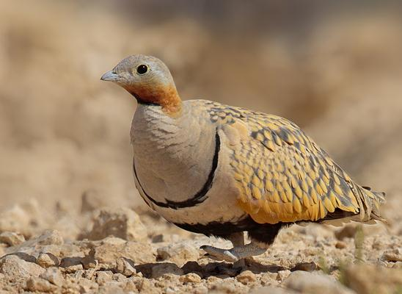](http://www.google.co.il/url?sa=i&rct=j&q=&esrc=s&source=images&cd=&cad=rja&uact=8&ved=0CAcQjRxqFQoTCNTkt8j6sMgCFYIsGgodi3oOGA&url=http://www.sustainability.org.il/home/biodiversity-news&psig=AFQjCNH_otTmTeCYoeRpkDKWYhVa8bcHQQ&ust=1444327710091587)14

[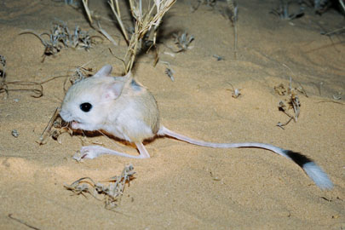](http://www.google.co.il/url?sa=i&rct=j&q=&esrc=s&source=images&cd=&cad=rja&uact=8&ved=0CAcQjRxqFQoTCNOCyOb2sMgCFQu-FAodNrUO1w&url=http://www.masa.co.il/article/2748/%D7%94%D7%A1%D7%9B%D7%A0%D7%94:-%D7%94%D7%9B%D7%97%D7%93%D7%94/&psig=AFQjCNHQUiUYTHHQchDXqzFPkIPwTbMR-g&ust=1444326567685435)15

[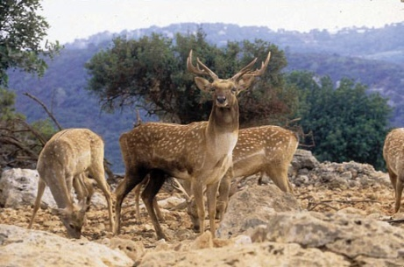](http://www.google.co.il/url?sa=i&rct=j&q=&esrc=s&source=images&cd=&cad=rja&uact=8&ved=0CAcQjRxqFQoTCNHC656LscgCFQTXGgod-HULRw&url=http://www.carmelim.org.il/%D7%A9%D7%9E%D7%95%D7%A8%D7%AA_%D7%94%D7%98%D7%91%D7%A2_%D7%97%D7%99_%D7%91%D7%A8&psig=AFQjCNEXwzOzzx-4ldo8OBNVlD8o1GpNqw&ust=1444332275655363)16

[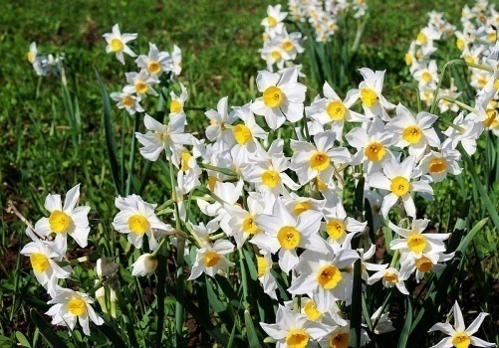](http://www.google.co.il/url?sa=i&rct=j&q=&esrc=s&source=images&cd=&cad=rja&uact=8&ved=0CAcQjRxqFQoTCKKvxKiPscgCFcu2GgodM9MADQ&url=http://www.pikiwiki.org.il/?action=gallery&img_id=38100&psig=AFQjCNGaGo8CoJmaPAfg7u1Fs53x5EYgTA&ust=1444333298748202)17

[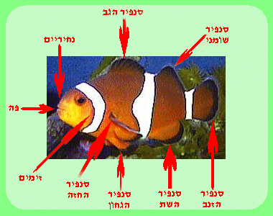](http://www.google.co.il/url?sa=i&rct=j&q=&esrc=s&source=images&cd=&cad=rja&uact=8&ved=0CAcQjRxqFQoTCNbC7r-QscgCFUJQGgodnOgGWg&url=http://www.gocool.co.il/home/fish/ant/ant.html&psig=AFQjCNG7mR9obRnz_-O7gccHzVhm6CUDwg&ust=1444333652891851)18

[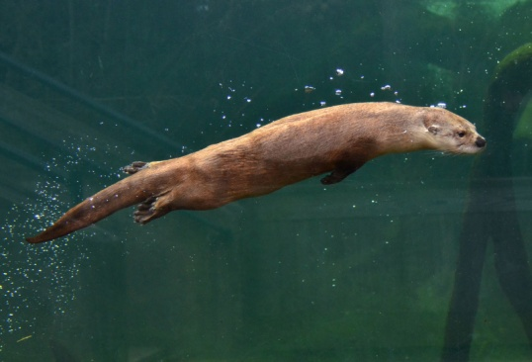](https://www.google.co.il/url?sa=i&rct=j&q=&esrc=s&source=images&cd=&ved=0CAcQjRxqFQoTCJ_puPaSscgCFQW-FAodQ3IMBA&url=https://thevlm.org/you-otter-be-in-pictures-2/&psig=AFQjCNFBJTf6S8S4Tr1_Zdx2jcExVQtWWQ&ust=1444334292165390)19

[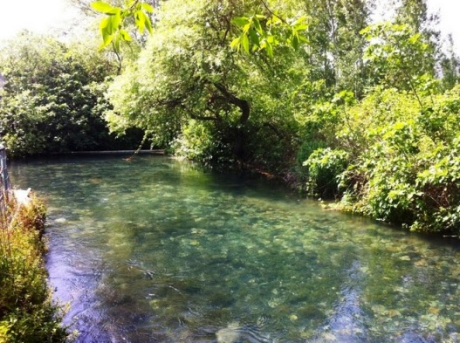](http://www.google.co.il/url?sa=i&rct=j&q=&esrc=s&source=images&cd=&cad=rja&uact=8&ved=0CAcQjRxqFQoTCIv2zpyVscgCFUi3FAodye4InQ&url=http://bareketjeeps.blogspot.com/&psig=AFQjCNG0LdOhG9O1Il32QwlTUhC7eMgGDw&ust=1444334854660007)20

[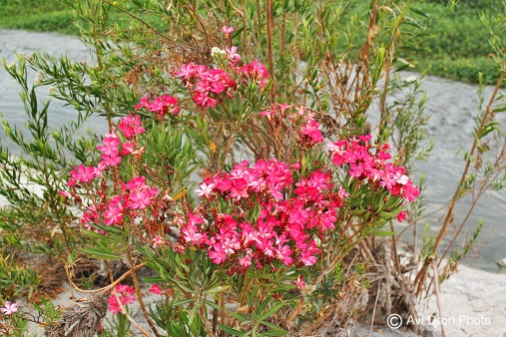](http://www.google.co.il/url?sa=i&rct=j&q=&esrc=s&source=images&cd=&cad=rja&uact=8&ved=0CAcQjRxqFQoTCPXV847-usgCFUduFAodAWEK1A&url=http://www.tapuz.co.il/blog/net/mobile/ViewEntry.aspx?EntryId=2769359&tads=1&bvm=bv.104819420,d.d24&psig=AFQjCNGcw-xqKD-VF008awZG-LkI3Vi0gQ&ust=1444672228640805)21

[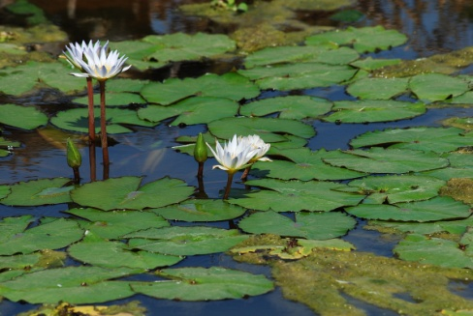](http://www.google.co.il/url?sa=i&rct=j&q=&esrc=s&source=images&cd=&cad=rja&uact=8&ved=0CAcQjRxqFQoTCKaA7v6WscgCFUFYFAodJ0IJgQ&url=http://www.picshare.co.il/view_member.asp?id=3454&psig=AFQjCNGtNhE9ony17KVhnsUvk7QTd0GVNg&ust=1444335354506904)22

[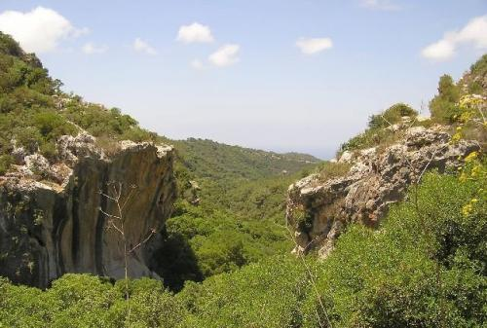](http://www.google.co.il/url?sa=i&rct=j&q=&esrc=s&source=images&cd=&cad=rja&uact=8&ved=0CAcQjRxqFQoTCPLN2I2Ku8gCFUFUGgod0nkAUg&url=http://cafe.themarker.com/image/1916053/&bvm=bv.104819420,d.d2s&psig=AFQjCNEzmKPEPXULLqhPl2vRzjHFzIoyqA&ust=1444675526731978)23

[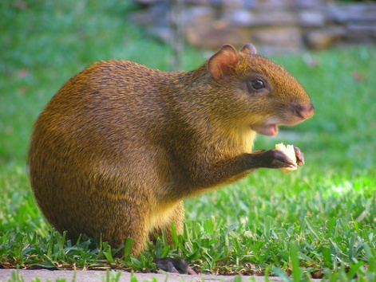](http://www.google.co.il/url?sa=i&rct=j&q=&esrc=s&source=images&cd=&cad=rja&uact=8&ved=0CAcQjRxqFQoTCKW4zd-YscgCFcW_FAodEPQKsg&url=http://www.flickriver.com/photos/15434282@N00/tags/roedor/&psig=AFQjCNEgrFVRjN_wcbiJrgUv5lWluA8SJw&ust=1444335887452603)24

[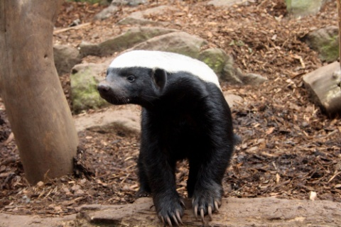](http://www.holesinthenet.co.il/holesinthenet-media-story-30640)25

[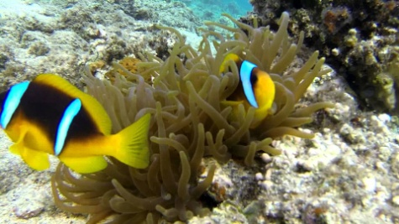](http://www.youtube.com/watch?v=3ZDJCpGwVMA)26

[](http://www.patpet.co.il/category/%D7%9B%D7%9C%D7%91%D7%99%D7%9D/)27

[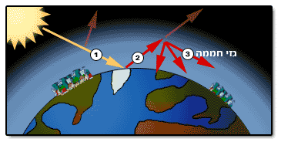](http://www.google.co.il/url?sa=i&rct=j&q=&esrc=s&source=images&cd=&cad=rja&uact=8&ved=0CAcQjRxqFQoTCKqdw67Ps8gCFczVGgodIAcHHQ&url=http://kids.gov.il/sababa/sababa_pool/pages/4343&bvm=bv.104615367,d.d2s&psig=AFQjCNEGwakHIInrd-1oUfThEzXDAPZccg&ust=1444419253101828)28

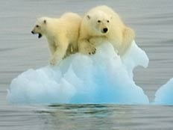29

[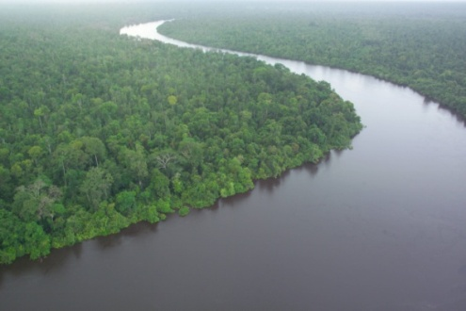](https://www.google.co.il/url?sa=i&rct=j&q=&esrc=s&source=images&cd=&cad=rja&uact=8&ved=0CAcQjRxqFQoTCLzW_aXG-8cCFcfrGgodiuUDTw&url=https://he.wikipedia.org/wiki/%D7%99%D7%A2%D7%A8_%D7%92%D7%A9%D7%9D_%D7%98%D7%A8%D7%95%D7%A4%D7%99&psig=AFQjCNFAQRVGLSlsyjWi9ghvV387Zhm_zQ&ust=1442492671543093)30

[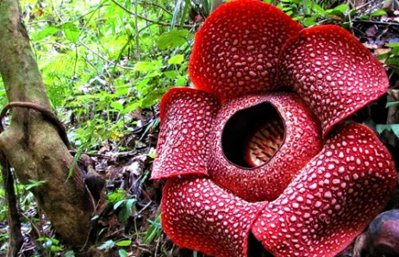](http://www.google.co.il/url?sa=i&rct=j&q=&esrc=s&source=images&cd=&cad=rja&uact=8&ved=0CAcQjRxqFQoTCPTg57rP-8cCFUc8FAodRhEB1A&url=http://www.indonesia-tourism.com/bengkulu/raflesia.html&bvm=bv.102829193,d.d2s&psig=AFQjCNGVsrOnKG48pbVWtiYfSXoeFRGKTQ&ust=1442495168176534)31

[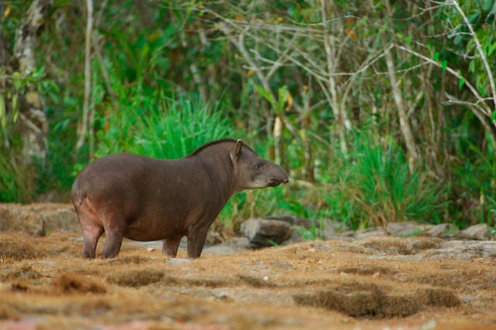](http://www.google.co.il/url?sa=i&rct=j&q=&esrc=s&source=images&cd=&cad=rja&uact=8&ved=0CAcQjRxqFQoTCIa3iIeVxcgCFQhwGgodoR4Pug&url=http://www.ynet.co.il/articles/0,7340,L-4532726,00.html&bvm=bv.105039540,d.d2s&psig=AFQjCNFCWUeokwj3DxihwTIoXUTWp5ZDoQ&ust=1445022022814246)32

[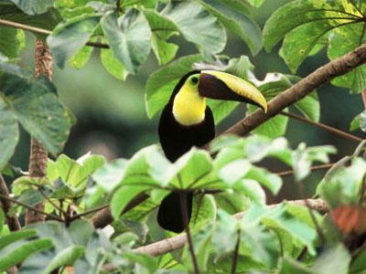](http://www.google.co.il/url?sa=i&rct=j&q=&esrc=s&source=images&cd=&cad=rja&uact=8&ved=0CAcQjRxqFQoTCP-Ar7nGs8gCFYI-FAod9c4D-Q&url=http://www.xplorer.co.il/map/central_america/costa_rica?i=cities&bvm=bv.104615367,d.d24&psig=AFQjCNEfE5Yx8rva7C7zH5XwIwAiiY3dAw&ust=1444416794458059)33  
[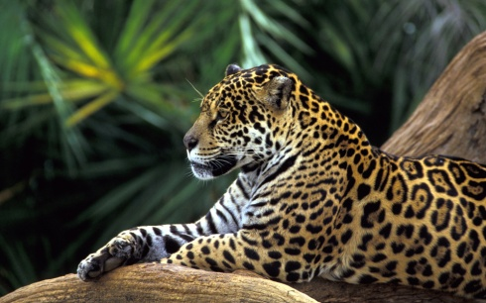](http://all4desktop.com/4170265-jaguar-in-amazon-rainforest.html)34

[](http://www.google.co.il/url?sa=i&rct=j&q=&esrc=s&source=images&cd=&cad=rja&uact=8&ved=0CAcQjRxqFQoTCKXP-MjKs8gCFUNbGgodZ4oFbg&url=http://www.sun-energy.co.il/articles/2315&bvm=bv.104615367,d.d2s&psig=AFQjCNEtdZXxUuKb5hoW657GA4qj-8fsyA&ust=1444417976694301)35

[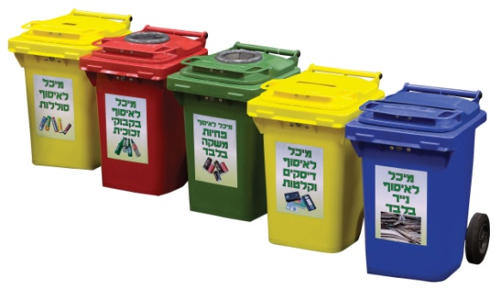](http://www.google.co.il/url?sa=i&rct=j&q=&esrc=s&source=images&cd=&cad=rja&uact=8&ved=0CAcQjRxqFQoTCLuhqYTMs8gCFUe0GgodHJsGmQ&url=http://www.dolav.co.il/data/products/environmental-products/&bvm=bv.104615367,d.d2s&psig=AFQjCNE3yYollqY1UM60cxeQ70xCEwiCdw&ust=1444418331743623)36

[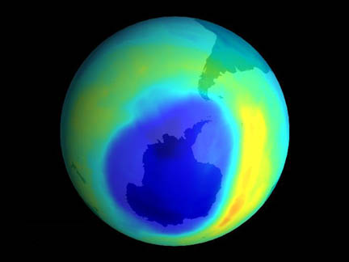](https://www.google.co.il/url?sa=i&rct=j&q=&esrc=s&source=images&cd=&cad=rja&uact=8&ved=0CAcQjRxqFQoTCIfZktHPs8gCFQk_Ggod_IEAeg&url=https://www.llnl.gov/archives/1970s&bvm=bv.104615367,d.d2s&psig=AFQjCNE2o4J1WFPXmkNXDniRp8dxsyliPg&ust=1444418869594825)37

[](http://www.google.co.il/url?sa=i&rct=j&q=&esrc=s&source=images&cd=&cad=rja&uact=8&ved=0CAcQjRxqFQoTCOql9qy15ccCFYY4Ggod-vkN7A&url=http://kids.gov.il/sababa/sababa_pool/pages/4352&psig=AFQjCNF2UpK7G11Zdmc5l0P1C_w8Uu85cg&ust=1441732262288070) 38

[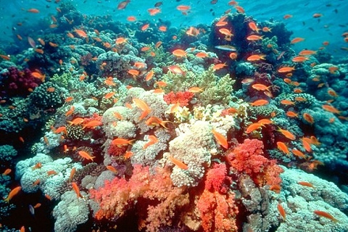](https://www.google.co.il/url?sa=i&rct=j&q=&esrc=s&source=images&cd=&cad=rja&uact=8&ved=0CAcQjRxqFQoTCO-RlsfUs8gCFQE9FAod-7kEVg&url=https://www.rimonim.com/eilat-attractions&bvm=bv.104615367,d.d2s&psig=AFQjCNESqC0SzF2w8X3S0NFRQp29Sj7LHQ&ust=1444420653405651)39

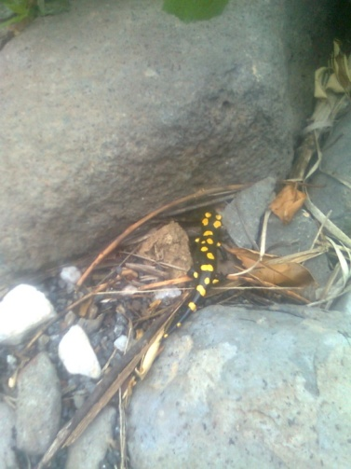40

[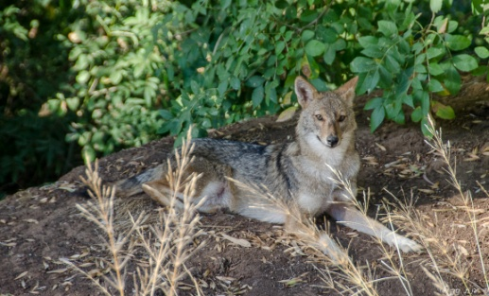](http://www.google.co.il/url?sa=i&rct=j&q=&esrc=s&source=images&cd=&cad=rja&uact=8&ved=0CAcQjRxqFQoTCKT-morZs8gCFUXvFAod1kwJfA&url=http://anatskili.blogspot.com/2015/03/blog-post_10.html&bvm=bv.104615367,d.d2s&psig=AFQjCNGm9nyGOX7U_abfLbU7GZDhFfgHwg&ust=1444421870875459)41

[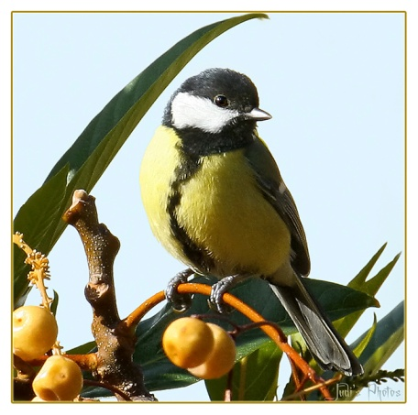](http://www.google.co.il/url?sa=i&rct=j&q=&esrc=s&source=images&cd=&cad=rja&uact=8&ved=0CAcQjRxqFQoTCN-Sp-rZs8gCFQQ5FAodOrEE0A&url=http://photolight.co.il/show_photo/151470&bvm=bv.104615367,d.d2s&psig=AFQjCNEgJidyDEWR7nm9A0j7QbS3emf5Qg&ust=1444422100850255)42

[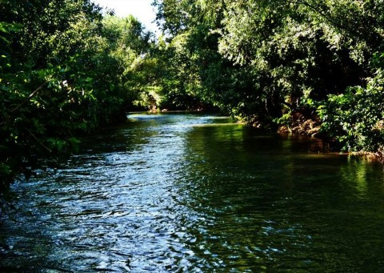](http://www.google.co.il/url?sa=i&rct=j&q=&esrc=s&source=images&cd=&cad=rja&uact=8&ved=0CAcQjRxqFQoTCMXhjrqkysgCFQq6FAodD7YP6A&url=http://tiulim.net/%D7%9E%D7%A1%D7%9C%D7%95%D7%9C-%D7%98%D7%99%D7%95%D7%9C-%D7%91%D7%A0%D7%97%D7%9C-%D7%A9%D7%A0%D7%99%D7%A8-%D7%97%D7%A6%D7%91%D7%90%D7%A0%D7%99/&bvm=bv.105454873,d.bGQ&psig=AFQjCNF7G3H6axpWgb06XCrivmibKnVBcA&ust=1445197967570265)43

[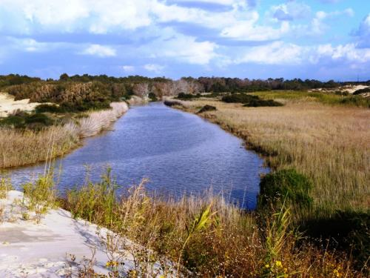](http://www.google.co.il/url?sa=i&rct=j&q=&esrc=s&source=images&cd=&cad=rja&uact=8&ved=0CAcQjRxqFQoTCLTc4p2nysgCFYa6FAodWBcNFg&url=http://cafe.themarker.com/image/2518822/&bvm=bv.105454873,d.bGQ&psig=AFQjCNFpy0APmPdFmyBFlSjPFoM029mmgA&ust=1445198751746365)44

[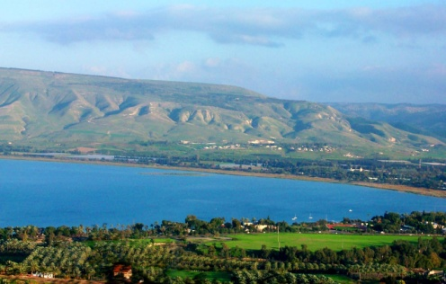](http://4.bp.blogspot.com/-vOXigs-zkOc/UeNDdscr2HI/AAAAAAAAAOo/7NTZKtxjqPo/s1600/sea+of+ga1.jpg)45

[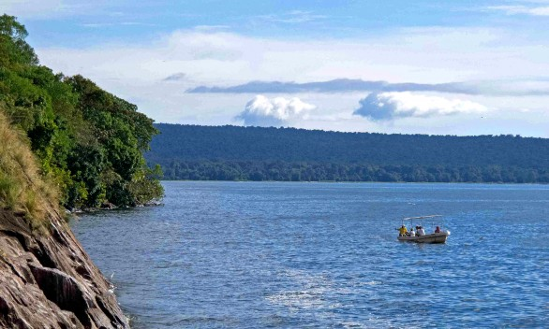](https://www.google.co.il/url?sa=i&rct=j&q=&esrc=s&source=images&cd=&cad=rja&uact=8&ved=0CAcQjRxqFQoTCKyOyO3es8gCFQpVFAodJuYPYQ&url=https://blog.enchanting-travels.com/2012/12/20/lake-victoria-wilderness-introducing-rubondo-camp/&psig=AFQjCNETyH2wQKT5EmHsAoOLfOOp7aFDFw&ust=1444423458844305)46

[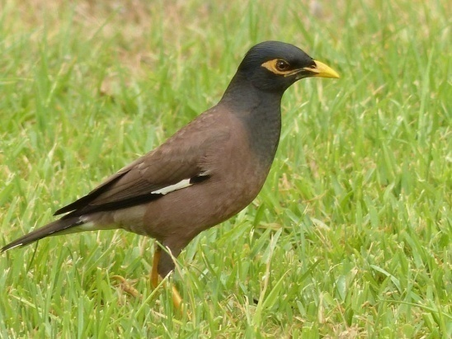](http://www.google.co.il/url?sa=i&rct=j&q=&esrc=s&source=images&cd=&cad=rja&uact=8&ved=0CAcQjRxqFQoTCIbsrZrgs8gCFUNaFAod68EGEQ&url=http://www.birdsbase.com/bbis_test/heb/photo.jsp?id=2248&psig=AFQjCNFi1MV6MYn5VmSrFzV-XewWOrc-ZQ&ust=1444423779904079)47

[](http://www.google.co.il/url?sa=i&rct=j&q=&esrc=s&source=images&cd=&cad=rja&uact=8&ved=0CAcQjRxqFQoTCIbL6p_Os8gCFQtVGgodMBkPlQ&url=http://clickit3.ort.org.il/Apps/WW/Page.aspx?ws=8e17c47e-b47b-4f0e-8c43-cf87cb54660f&page=645c2836-92bd-4707-b3da-4c259c94f7d3&bvm=bv.104615367,d.d2s&psig=AFQjCNFPPyy5RXMDxfOhoctreL6GUdzzLw&ust=1444418986267907)48